

TASCO Motor Insurance Growth Platform · TGP-MAN-01
Staff Console User Manual
Date – 08 October 2026
Version – 1.0
Prepared by – iorta TechNXT
TABLE OF CONTENTS
1. Document Control 6
2. Acronyms 6
3. Introduction 7
3.1. Purpose 7
3.2. Scope 7
3.3. Audience 7
3.4. Golden rules 7
3.5. Related documents 7
4. Getting started 8
4.1. What you need 8
4.2. Sign in 8
4.3. Two-step verification 9
4.4. Your start page 10
4.5. Screen layout 10
4.6. Global search 11
4.7. Notifications 11
4.8. Help 12
4.9. User menu, language and theme 13
4.10. Session length and lockout 13
4.11. Common patterns 14
4.11.1. Page header 14
4.11.2. Tables 14
4.11.3. Row actions 14
4.11.4. Drawers and confirmations 14
4.11.5. Status chips and SLA chips 14
4.11.6. Masked personal data 15
4.11.7. Error messages 15
5. Executive 15
5.1. What the role is for 15
5.2. Daily routine 15
5.3. Read the dashboard 15
5.4. What to check 16
6. Campaign manager 17
6.1. What the role is for 17
6.2. Daily routine 17
6.3. Read your dashboard 18
6.4. Find a target segment 18
6.5. Run due touchpoints 19
6.6. Simulate an ecosystem event 19
6.7. Launch a voice campaign 20
6.8. Review campaign results 21
6.9. Request a change to journeys, messages or scoring 21
6.10. What to check 21
7. Telesales supervisor 22
7.1. What the role is for 22
7.2. Daily routine 22
7.3. Read your dashboard 22
7.4. Manage the queue 23
7.5. Reassign a handoff 24
7.6. Correct an outcome 25
7.7. Coaching checklist 25
7.8. What to check 25
8. Telesales agent 26
8.1. What the role is for 26
8.2. Daily routine 26
8.3. Work a handoff 27
8.3.1. Open and read the call brief 27
8.3.2. Call 28
8.3.3. Quote 28
8.3.4. Send the quote to the customer 29
8.3.5. Record the outcome 30
8.4. Customer 360 30
8.5. Rehearse a call 31
8.6. Handling common objections 31
8.7. What to check 32
9. Rule author and approver 32
9.1. What the role is for 32
9.2. Daily routine 32
9.3. Find a rule set 32
9.4. Author a change 33
9.5. Simulate before you submit 33
9.6. Submit for approval 34
9.7. Roll back 34
9.8. Review and approve a change 34
9.9. What to check 36
10. Compliance officer 36
10.1. What the role is for 36
10.2. Daily routine 36
10.3. Approve a restricted change 37
10.4. Review voice assistant compliance 37
10.5. Search the audit trail 38
10.6. Data subject requests 39
10.7. What to check 39
11. Data steward 39
11.1. What the role is for 39
11.2. Daily routine 39
11.3. Read the queue 39
11.4. Resolve an issue 40
11.5. Assign or dismiss several issues 41
11.6. Correct an expiry date from Customer 360 42
11.7. Data loads 42
11.8. What to check 42
12. Claims handler 43
12.1. What the role is for 43
12.2. Daily routine 43
12.3. Read the queue 43
12.4. Move a claim through its steps 44
12.5. Reject a claim 44
12.6. Read a claim 45
12.7. What to check 45
13. Partner manager 46
13.1. What the role is for 46
13.2. Daily routine 46
13.3. Onboard a partner 46
13.4. Issue an API key 47
13.5. Revoke a key, suspend or reactivate a partner 47
13.6. Commission statements 47
13.7. What to check 48
14. Administrator and support 48
14.1. What the role is for 48
14.2. Daily routine 48
14.3. Manage users 49
14.3.1. Create a user 49
14.3.2. Change roles, unlock, reset or disable 50
14.4. Monitor operations 50
14.5. Run a job by hand 52
14.6. What to check 52
15. Auditor 53
15.1. What the role is for 53
15.2. Daily routine 53
15.3. Review the audit trail 53
15.4. Review sign-in activity 54
15.5. Review rule versions 55
15.6. What to check 55
16. Troubleshooting and support 55
16.1. Common problems 55
16.2. Getting help 56
16.3. Responsible use 56
17. Appendix 56
17.1. Role and permission summary 56
17.2. Page names in Vietnamese 57
17.3. Glossary of status names 58
17.3.1. Telesales handoffs 58
17.3.2. SLA chips 58
17.3.3. Claims 58
17.3.4. Rule versions 58
17.3.5. Leads, journeys and calls 58
17.3.6. Data issues 59
17.3.7. Partners, keys, users and integrations 59
18. Sign-Off 60

Document Control

Date | Version | Author & Business Unit Info | Reviewed By & Business Unit Info | Approved By & Business Unit Info | Change History
08/10/2026 | 1.0 | iorta TechNXT  Business Analysis and User Experience | TASCO Insurance  Product Owner | TASCO Insurance  Programme Sponsor | Initial issue for submission

Acronyms

Acronym / Symbol | Definition / Meaning
API | Application programming interface
CSV | Comma-separated values (spreadsheet export)
IP | Internet Protocol (network address)
MFA | Multi-factor authentication (two-step verification)
OTP | One-time password
QR | Quick response (code)
SLA | Service level agreement
SMS | Short message service
TNDS | Compulsory motor third-party liability insurance (Bảo hiểm TNDS bắt buộc)
UAT | User acceptance testing
VAT | Value-added tax
ZNS | Zalo Notification Service

Introduction

Purpose
This manual explains how TASCO Insurance and VETC staff use the staff console of the TASCO Growth Platform. It covers signing in, the screen layout and the patterns every page shares, and then gives one chapter per role with the daily routine and step-by-step tasks.

Scope
The manual describes version 1.0 of the staff console as delivered for user acceptance testing. Screen labels are quoted in English, as they appear when the console language is set to English. The console opens in Vietnamese by default; section “Language” in the Getting started chapter shows how to switch, and the Appendix lists the Vietnamese names of the main pages.
The customer app is covered by TGP-MAN-02 Customer App Guide, and partner system integration by TGP-MAN-03 Partner API Integration Guide.

Audience
Every staff user of the console: executives, campaign managers, telesales supervisors and agents, rule authors and approvers, compliance officers, data stewards, claims handlers, partner managers, administrators, support engineers and internal auditors. Read the Getting started chapter first, then the chapter for your role.

Golden rules
Three rules apply to every role and are built into the console.
- TNDS premiums are set by regulation and are the same at every insurer. Never offer or mention a discount, rebate or cashback on TNDS. TASCO competes on service: roadside assistance, the e-certificate, renewal reminders and fast claims.
- Staff never take payment, card details or OTP codes. A quote is sent to the customer’s app, and the customer confirms and pays there.
- Open a customer record only when your work needs it. Every view is recorded in the audit trail.

Related documents
ID | Title
TGP-BUS-02 | Functional Requirements Specification
TGP-BUS-06 | Personas and Customer Journeys
TGP-UX-03 | Information Architecture and Navigation
TGP-OPS-01 | Runbook and Support Guide
TGP-DEL-06 | Organisational Change and Training Plan
TGP-MAN-02 | Customer App Guide
TGP-MAN-03 | Partner API Integration Guide

Getting started

What you need
You need | Notes
A user account | Created by a platform administrator after training. Each account has one or more roles and a data region (a province or All regions).
A supported browser | A current version of Chrome, Edge, Firefox or Safari. A screen at least 1,280 pixels wide works best.
An authenticator app | Needed for the Administrator, Rule approver, Compliance officer and Data steward roles. Microsoft Authenticator, Google Authenticator or a similar app.
The console address | Given by TASCO IT for production, and by your trainer for training and UAT.

Sign in
- Open the console address. The sign-in page shows the TASCO brand panel on the left and the Sign in form on the right.
- Enter your Username and Password. The eye icon in the password field shows or hides what you typed; a warning appears when Caps Lock is on.
- Select Sign in.
If your role does not need two-step verification, the console opens on your start page and greets you by name. If it does, the Two-step verification step appears.
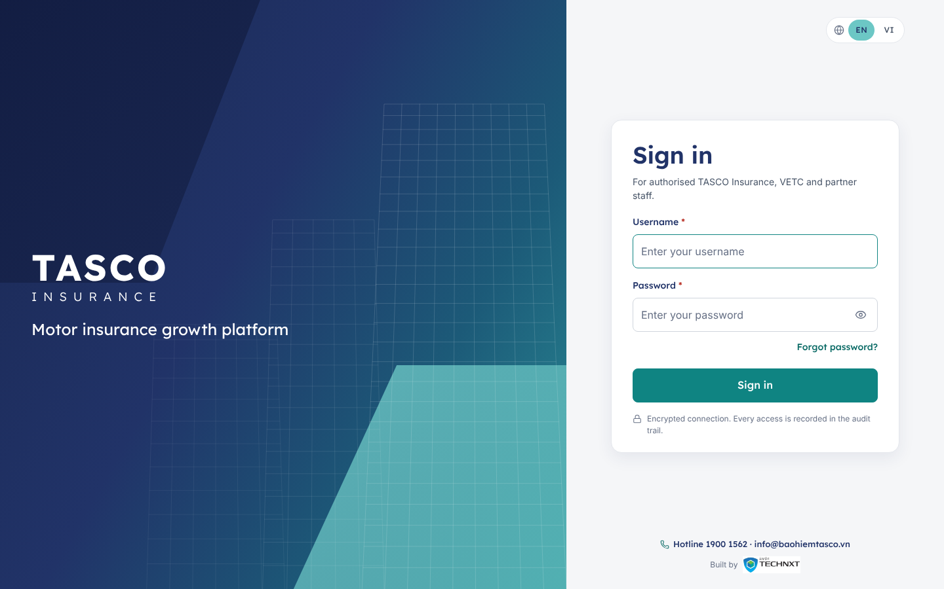
Figure 1 – Sign-in page
Forgot password? under the password field explains what to do: ask your system administrator to reset it. For security, passwords are never sent by e-mail.
The hotline and support e-mail shown at the foot of the page are TASCO’s customer channels. Staff with sign-in problems contact their own service desk.

Two-step verification
The first time you sign in with a role that needs two-step verification, the page shows a QR code.
- Open your authenticator app and scan the QR code. If you cannot scan it, open Can’t scan? Enter the key manually and type the key into the app.
- The app shows an entry for the TASCO Growth Platform with a six-digit code that changes every 30 seconds.
- Type the code into the six boxes under 6-digit authentication code. The form submits itself when the sixth digit is entered; you can also select Verify.
At every later sign-in, only the six boxes appear. Each code can be used once: if you signed in a moment ago, wait for the next code. You have five minutes to complete this step before you must start again from the password. Use a different account takes you back to the first step.
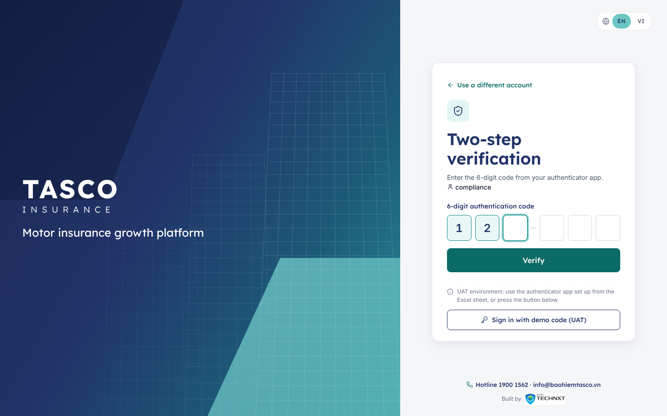
Figure 2 – Two-step verification
In the UAT environment only, the step also shows Sign in with demo code (UAT), which fills in the current code for a demo user. This button does not exist in production.

Your start page
The console opens on the first page your role may use.
Role | Start page
Executive, campaign manager, telesales supervisor, rule author, rule approver, compliance officer, data steward, partner manager, auditor, administrator | Dashboard, with figures chosen for the role
Telesales agent | Dashboard, shown as My work today
Claims handler | Claims
Support engineer | Operations

Screen layout
Every page has the same frame.
- The teal utility strip at the very top shows the TASCO Hotline (1900 1562) on the left. On the right are the environment badge (UAT in the test environment only), the EN / VI language switch and your user menu.
- The top bar under it shows the breadcrumb (where you are), the customer search box, the notifications bell and Help.
- The sidebar on the left lists only the pages your role may use, in groups. A number badge on a page shows work waiting for you.
- The footer reads “© 2026 TASCO Insurance · Powered by iorta TechNXT · v1.0”.
Sidebar group | Pages
(none) | Dashboard
Sell | Leads, Telesales inbox, Voice assistant
Engage | Journeys, Campaigns
Serve | Claims
Partners | Partners
Data | Data quality
Governance | Business rules, Approvals, Audit
Administration | Users, Operations
Collapse sidebar at the foot of the sidebar reduces it to icons; hover over an icon to see the page name. The console remembers this choice on your computer. On a narrow screen the sidebar is hidden behind the menu button at the left of the top bar.

Global search
Roles that can view customers have a search box in the top bar: Search plate or phone….
- Select the box, or press the / key anywhere outside a text field.
- Type at least three characters of a licence plate, or a full phone number.
- Pick a result with the mouse or the arrow keys and Enter. Each result shows the formatted plate, owner name, region and expiry date.
The customer opens in Customer 360 (see the Telesales agent chapter).

Notifications
The bell in the top bar appears for roles that have work to act on. Its badge counts waiting items, and the panel lists the most recent ones.
Item | Who sees it | Opens
New hot lead | Telesales agents and supervisors | Telesales inbox
Awaiting approval | Rule approvers and compliance officers (changes they may decide) | Approvals
SLA due soon / SLA breached | Claims handlers (claims to acknowledge within 2 hours, or overdue) | Claims
Open data issues | Data stewards | Data quality
When nothing is waiting, the panel shows “You’re all caught up”.
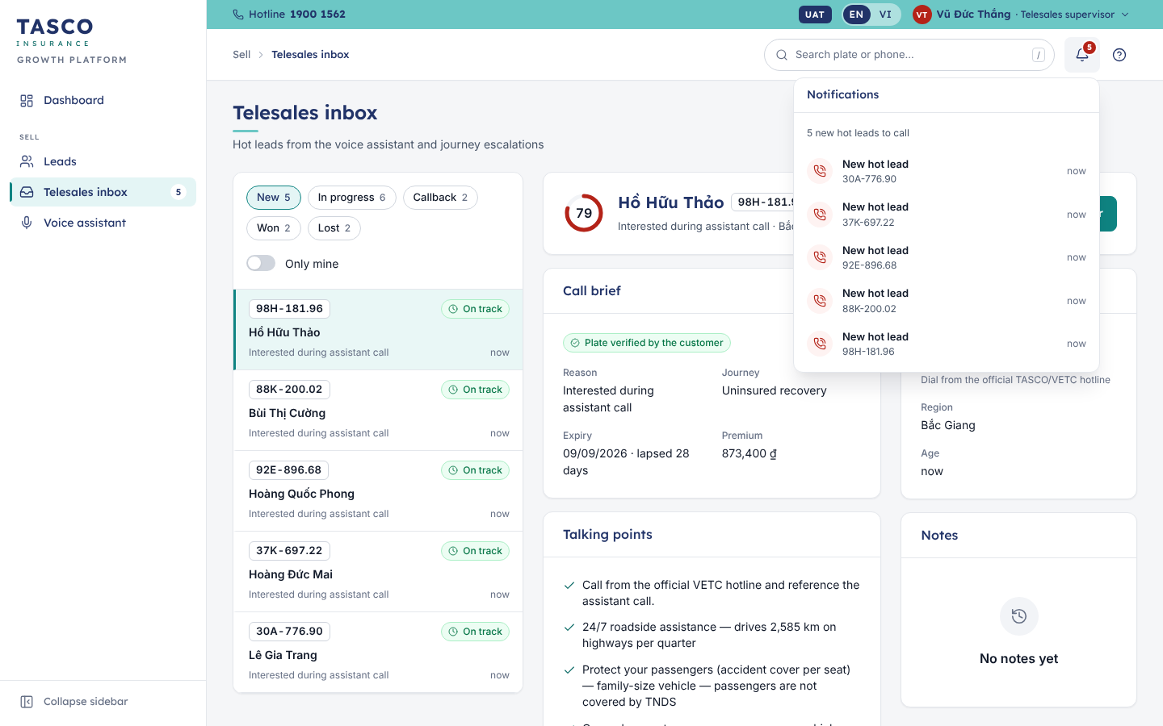
Figure 3 – Notifications panel

Help
Help (the question-mark icon in the top bar) opens a short panel about the page you are on: what it is for and the two or three points that matter most. Press Esc or select the close icon to return. This manual is the full reference.
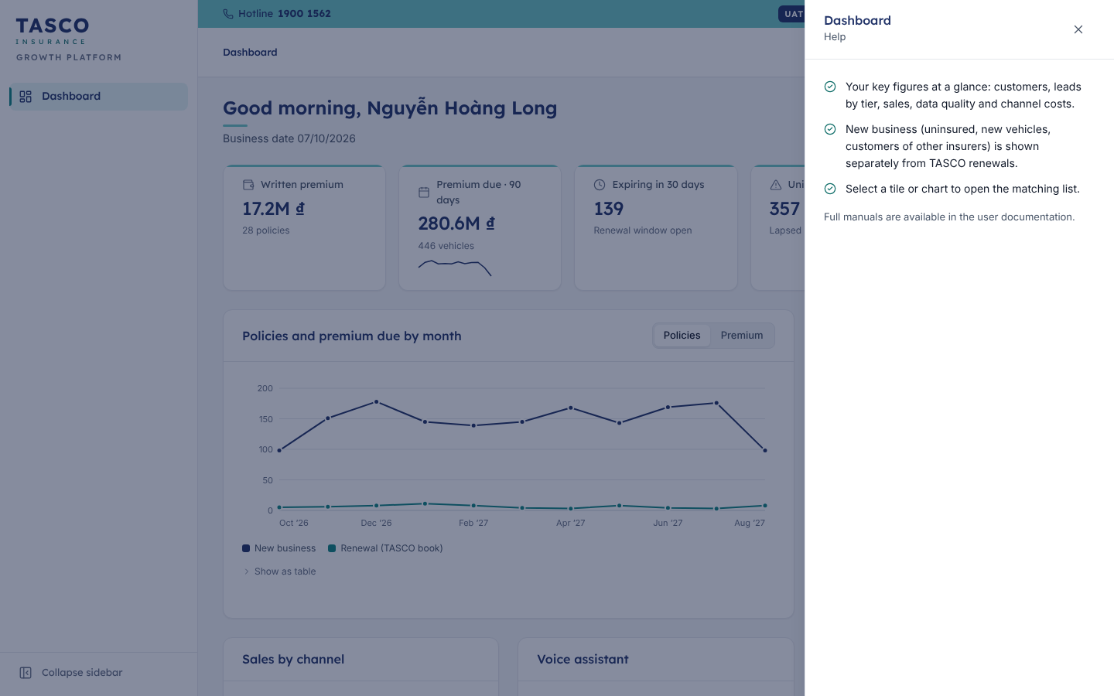
Figure 4 – Contextual help

User menu, language and theme
Select your name in the utility strip to open the user menu. It shows your name, roles and data region, and holds:
- Language: English or Tiếng Việt. The EN / VI switch in the strip does the same. Data such as plates, names and rule names is never translated.
- Theme: Light, Dark or System (follows your computer’s setting).
- Change password: enter the Current password and a New password of at least 12 characters, then Save. You are signed out everywhere and sign in again with the new password.
- Sign out. Always sign out on a shared computer.
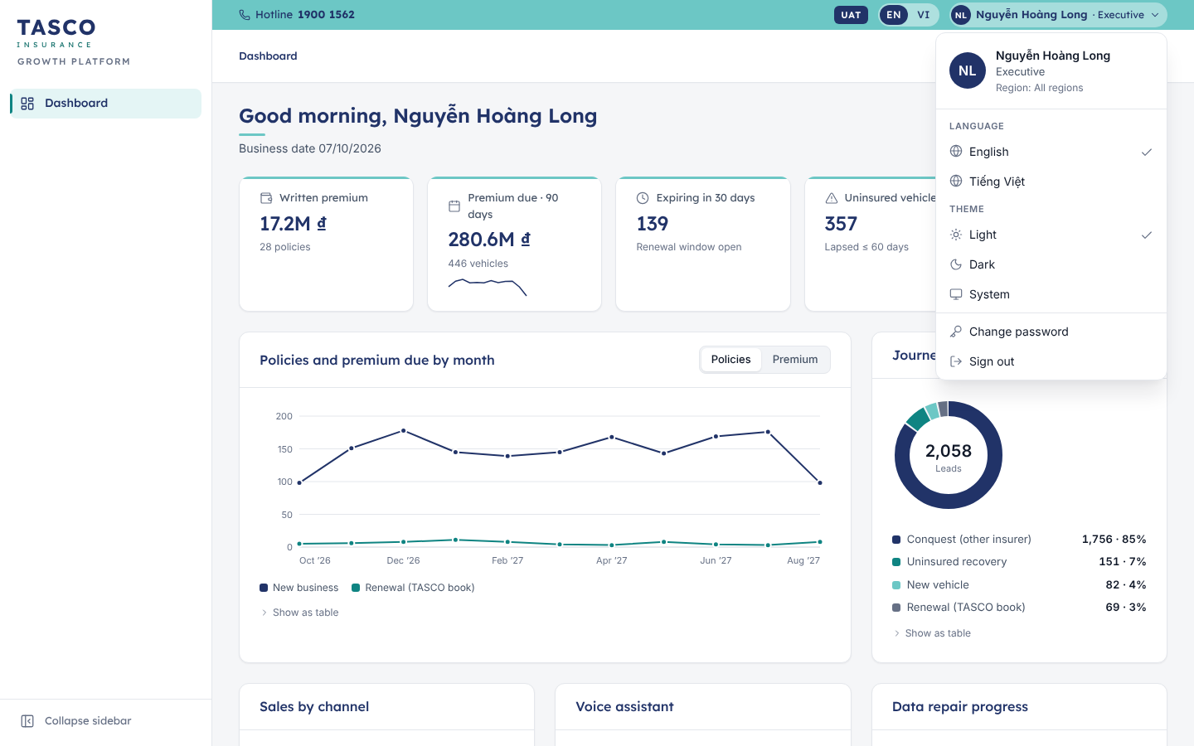
Figure 5 – User menu
If an administrator created your account or reset your password, the dialog Please set your own password opens straight after sign-in and cannot be closed until you have set one.

Session length and lockout
A session lasts 30 minutes. When it ends, the console shows “Session expired — please sign in again” and returns to the sign-in page.
After five failed attempts (wrong password or wrong code, counted together) the account is locked for 15 minutes and the sign-in page says “Your account is temporarily locked after several failed attempts”. Wait, or ask an administrator to unlock it.

Common patterns
The pages share a small set of patterns. Learn them once.

Page header
Each page has a title, an optional one-line subtitle and its main action at the top right, for example New campaign or Rehearse a call. Many pages then show a strip of figure tiles. A tile you can select filters the list below it.

Tables
Lists are tables with a toolbar above them.
- The search box filters the rows as you type.
- Filter chips narrow the list, for example Hot, Warm and Nurture on Leads. A chip with an arrow opens a list of values; Clear filters removes them all.
- Column headers with an arrow can be sorted; select again to reverse the order.
- Export CSV downloads the rows you are looking at, with business labels, for use in a spreadsheet.
- At the foot, Rows per page and the range (“1–25 of 2,223”) with previous and next arrows.
Select a row to open it, either in a new page, a right-hand drawer, or the detail panel next to the list.

Row actions
Workflow tables have one primary action per row, named after what you do next (“Acknowledge”, “Resolve…”, “View statement”). Secondary and negative actions sit in the More actions menu (the three-dot button). Closed records show a muted View action instead.

Drawers and confirmations
Details and forms open in a drawer on the right of the screen, so the list stays in place. Press Esc or select the close icon to leave it.
Decisions that change a record, such as approving a claim or rejecting a rule change, take two steps. You fill in the form and select Review; the dialog then shows a summary (“Check the details before you confirm”) and the confirm button, for example Confirm approval. Back returns to the form. A message in the corner (a toast) confirms the result.

Status chips and SLA chips
A record’s status is shown once, as a coloured chip: green for completed or healthy, amber for waiting or due soon, red for rejected or breached, grey for closed or neutral. The Appendix lists every status name.
Work with a deadline also shows an SLA chip: On track, Due soon or Breached, with the time left or overdue (“1h 20m left”, “35m over”). Hover over the chip to see the exact due time.

Masked personal data
If your role may not see personal data, names and phone numbers appear masked (for example “N. V. An”, “0912 *** 678”) with a lock icon. This is expected.

Error messages
An error appears as a red toast with a plain message and a reference such as “Ref. 7F3C2A1B”. Give this reference to the service desk; it identifies the request in the logs.

Executive

What the role is for
Executives in the CEO office and sales leadership follow growth, renewal and data repair at a glance. The role is read-only: it sees the Dashboard and nothing else, and never sees customer personal data.

Daily routine
Open the Dashboard once a day, or before a sales meeting. It takes about five minutes to read.

Read the dashboard
The figure tiles at the top show only figures that have data.
Tile | What it means
Written premium | Premium of policies sold through the platform, with the number of policies
Premium due · 90 days | Premium of TASCO renewals and new business falling due in the next three months, with the number of vehicles and a trend line
Expiring in 30 days | Vehicles whose cover ends within 30 days (renewal window open)
Uninsured vehicles | Vehicles whose cover lapsed within the last 60 days
Voice saving | Cost saved by the voice assistant compared with the same calls made by telesales
Below the tiles:
- Policies and premium due by month shows new business and TASCO renewals by month. The Policies / Premium switch changes the measure.
- Journey mix shows how leads divide between renewal, conquest (customers of other insurers), new vehicles and uninsured recovery.
- Sales by channel shows where policies were sold (VETC app, Zalo, telesales, partner API). When only one channel has sales, the card shows Policies by product instead.
- Voice assistant shows calls made, hot handoffs to telesales and renewal links sent, with the main call outcomes.
- Data repair progress shows the share of vehicles with a reliable expiry date and the top open data issues.
Every chart has Show as table under it for the exact numbers.
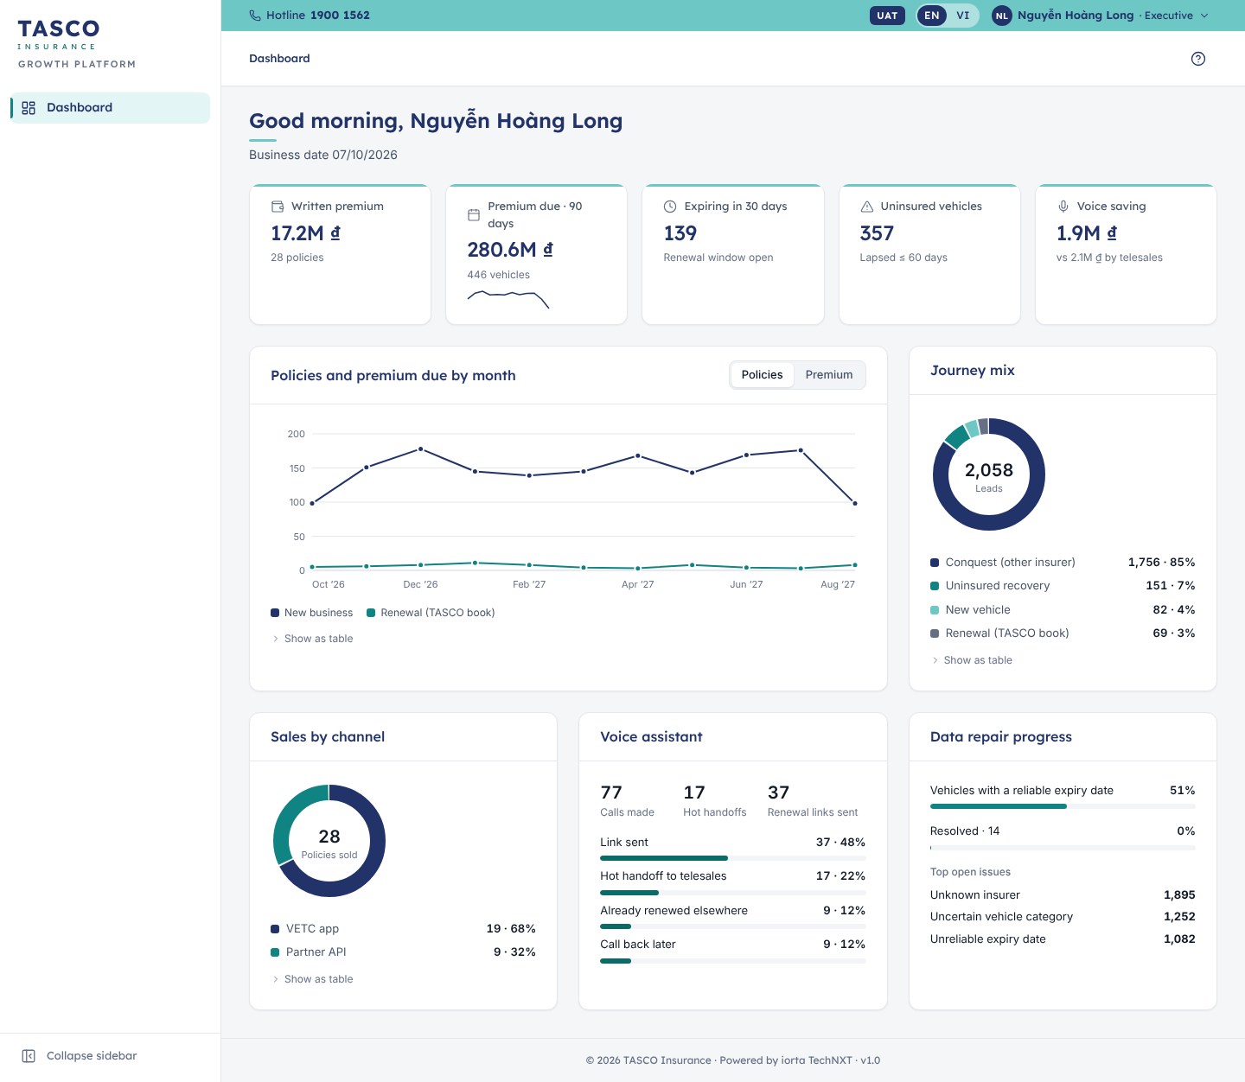
Figure 6 – Executive dashboard

What to check
- Premium due in the next 90 days against the sales target.
- Uninsured vehicles: a rising number means recovery journeys or telesales capacity need attention.
- Data repair progress: sales depend on reliable expiry dates.
- Any figure that looks wrong: ask the campaign manager or the data steward before drawing conclusions. The figures come from the platform, not from TASCO core, so they can differ slightly from finance reports.
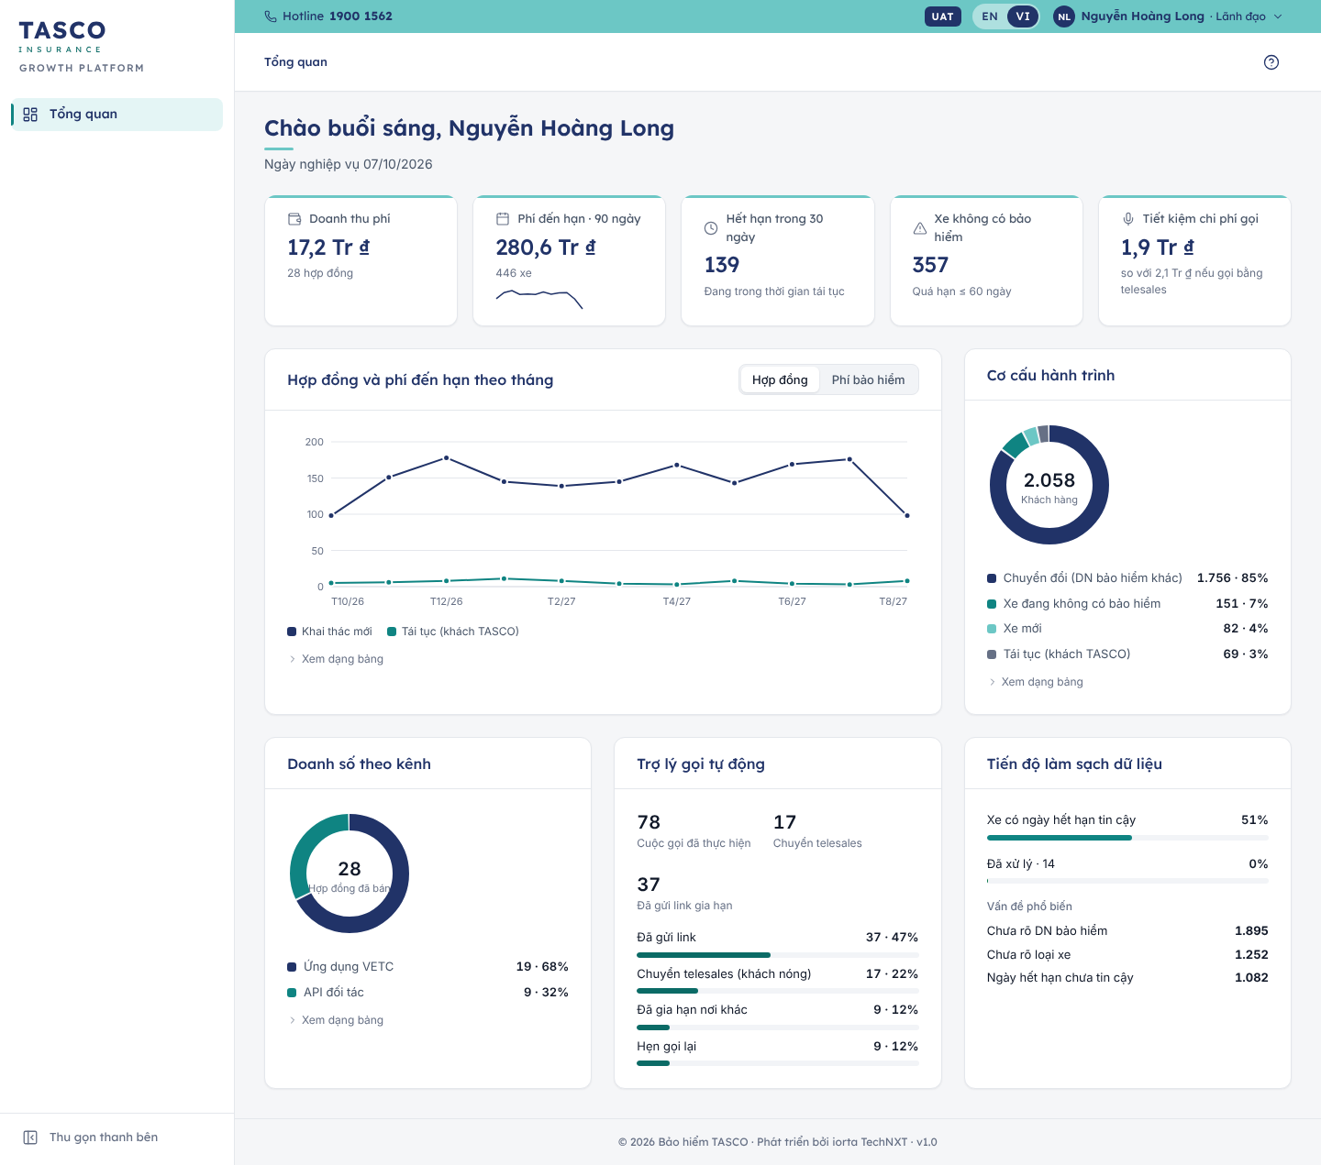
Figure 7 – Executive dashboard in Vietnamese

Campaign manager

What the role is for
The campaign manager decides who TASCO contacts, when and through which channel. The role works with leads, journeys, voice and messaging campaigns, and reads the business rules. It can open Customer 360 with personal data masked, and sees the telesales inbox read-only.

Daily routine
- Open the Dashboard. Check Due today and select Run due touchpoints if the scheduled run has not happened.
- Review Pipeline by journey and Campaign performance.
- Plan or launch a voice campaign for hot or warm leads with New campaign.
- Check the results of the previous day’s campaigns.
- Once a week, review the journeys and raise any change to cadences or message wording with the rule author.

Read your dashboard
The tiles show Hot leads (with the warm count), Due today or Due in 7 days, Messages sent, Calls made and Policies sold. Select Hot leads to open the hot-tier lead list.
Pipeline by journey lists leads per journey with the touchpoints due today and in the next seven days; select a row to open those leads. Campaign performance lists the five latest campaigns; Messages by channel shows the split between app notifications, Zalo ZNS and SMS.
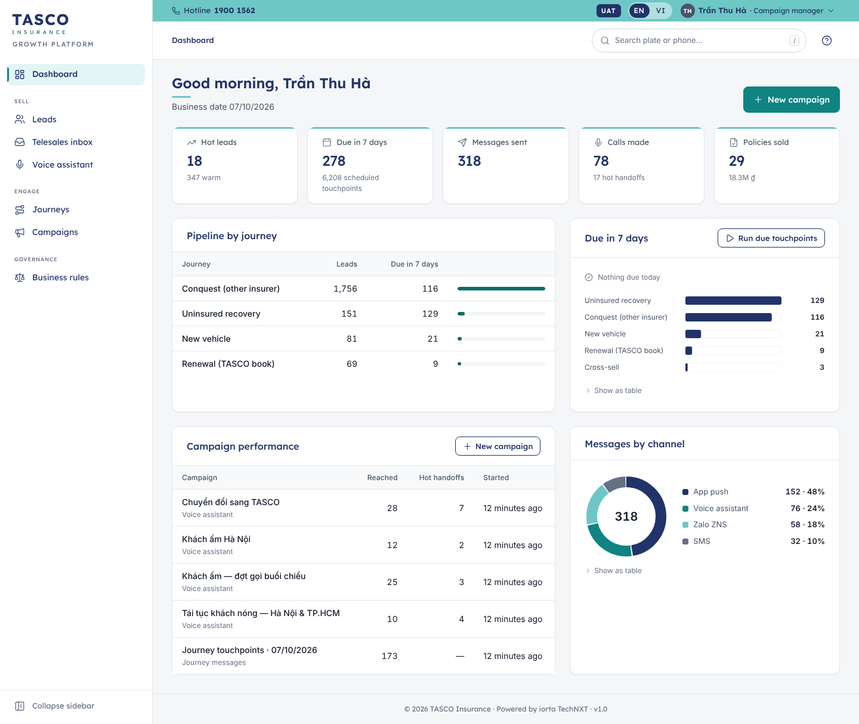
Figure 8 – Campaign manager dashboard

Find a target segment
- Select Leads in the sidebar.
- Select a tier chip: Hot (score 70 or more), Warm (45 or more) or Nurture.
- Use the Journey, Next best action and Region chips to narrow the list.
- Sort by Score or by Expiry with the column headers.
- Select Export CSV to take the list into a spreadsheet for planning.
Each row shows the vehicle, score, tier, journey, expiry date (“in 22 days”, “lapsed 25 days”), next best action, region and premium. Select a row to open Customer 360.
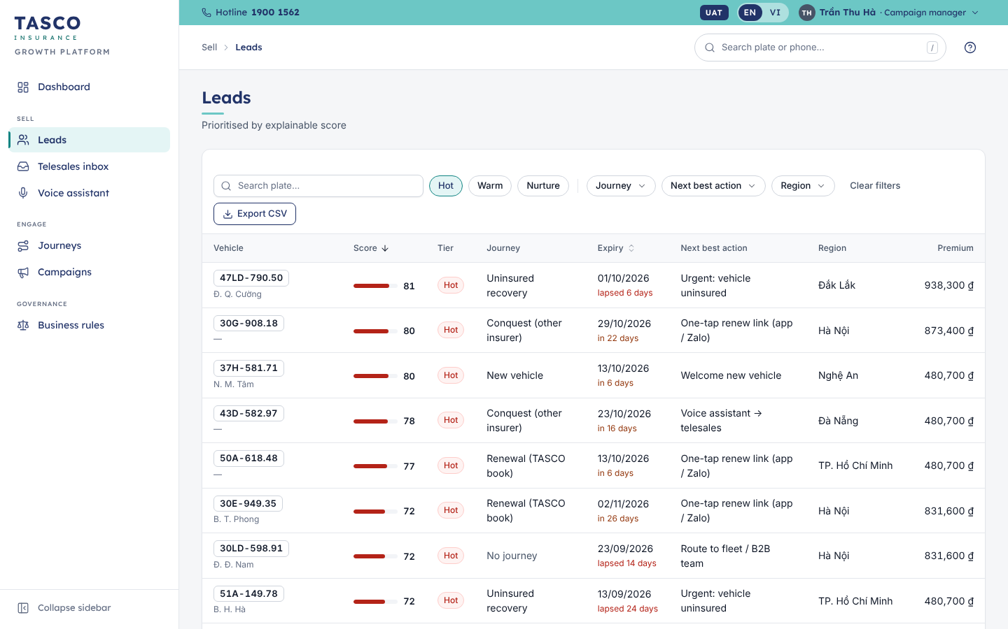
Figure 9 – Leads filtered to the hot tier

Run due touchpoints
Journeys send reminders on fixed days before or after the policy expiry. A scheduled job normally sends them; you can also run them by hand.
- Select Journeys in the sidebar. Each journey card shows its cadence (for example D−45, D−30, D−7, D0), the channels per step and its figures: In journey, Due in 7 days, Sold and Conversion.
- Select Run due touchpoints.
- Check the Business date and Send time (local).
- Select Run now.
The toast reports how many touchpoints were sent and how many skipped. The results card lists them by channel. A touchpoint is skipped when the contact policy does not allow it: outside contact hours (08:00 to 20:00), no consent, daily or weekly limit reached, or blocked by the copy guard. Skipped touchpoints show the reason in the customer’s Journey tab.
Next scheduled touchpoints at the foot of the page lists what is coming, with the due date, vehicle, journey, step, channels and status.

Simulate an ecosystem event
VETC events such as a new ETC tag, an inspection booking, a wallet top-up or a long highway trip can trigger a message. To test a trigger in UAT or training:
- On Journeys, select Simulate ecosystem event.
- Choose the Event and type the Customer plate, for example 30E-949.35.
- Select Send event.
The result shows what happened: “Message sent”, “Conditions not met”, “No permitted channel” or “Blocked by content rules”.
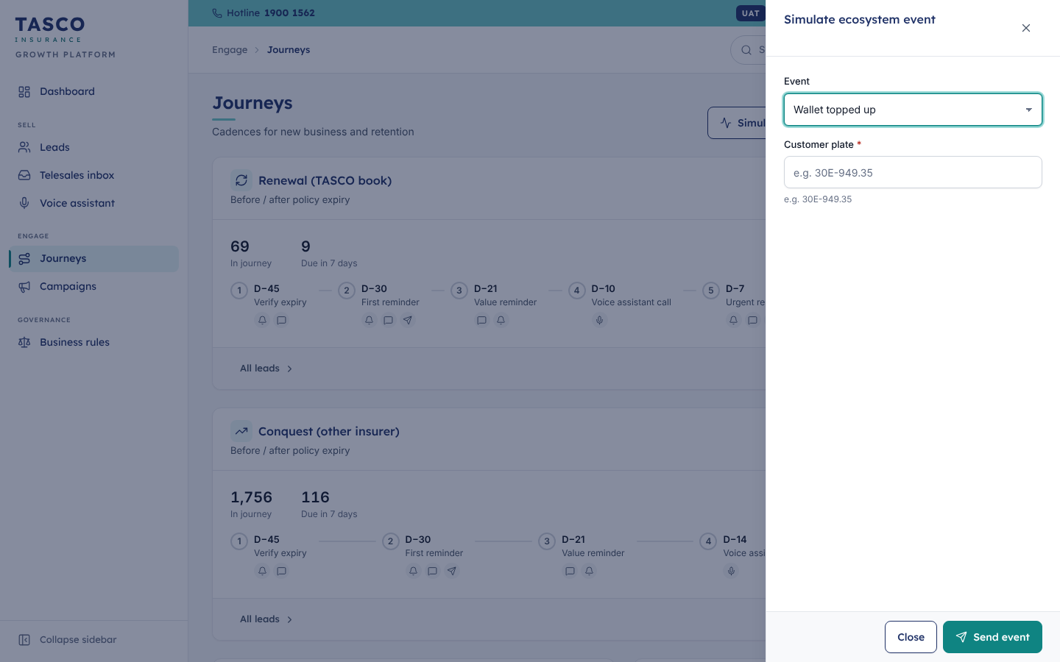
Figure 10 – Simulate an ecosystem event

Launch a voice campaign
- Select Campaigns in the sidebar, then New campaign. You can also start from the Dashboard or the Voice assistant page.
- Under Channel, keep Voice assistant. (Journey messages sends every touchpoint that is due, as in “Run due touchpoints”.)
- Give the campaign a Name your team will recognise (optional).
- Under Audience, choose the Lead tier (Hot or Warm), the Journey and the Region.
- Under Calling window, set the Date, the Start time (local) and the Maximum calls (1 to 200). Calls only go out inside the allowed contact hours.
- Read the Contact-policy preview on the right. It shows how many customers are In audience, how many Can be contacted and how many Will be called, and why others are Held back by contact policy (for example “No call consent” or “Weekly call limit reached”). Company vehicles are counted under Routed to fleet team and are not called.
- Select Launch campaign.
The toast reports how many customers were reached and how many became hot handoffs. Hot handoffs appear at once in the Telesales inbox.
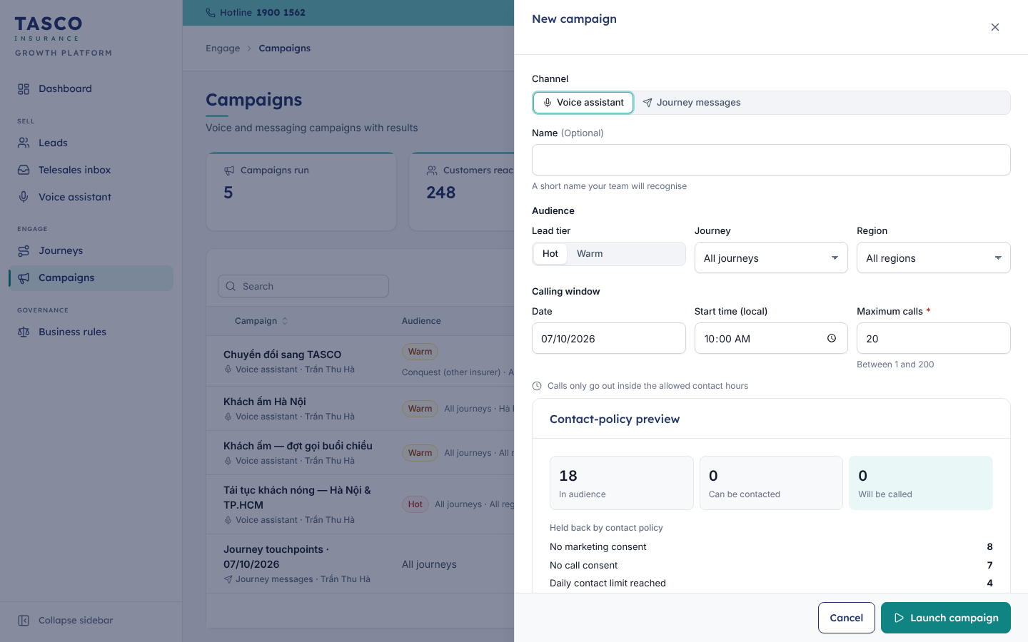
Figure 11 – New voice campaign

Review campaign results
On Campaigns, the tiles show Campaigns run, Customers reached, Hot handoffs and Renewal links sent. Select a campaign row to open its results: audience, maximum calls, customers reached, a chart of call outcomes and a chart of customers held back by the contact policy.
To listen in on what the assistant said, open Voice assistant, filter by Outcome and select a call. The call drawer shows the plate check, outcome, number of exchanges, duration and the full transcript in Vietnamese; switch on Show English translation to read it in English. Open handoff goes to the telesales handoff the call created.

Request a change to journeys, messages or scoring
The campaign manager reads the rules but does not change them. To change a cadence, a message or the scoring, send the rule author the request with the reason and, ideally, the expected effect. The change follows the maker-checker process in the Rule author and approver chapter.

What to check
- Skipped touchpoints rising: consent or contact data may be poor, or a cap is too tight.
- Hot handoffs not picked up: tell the telesales supervisor before launching more calls.
- Opt-out and scam-concern outcomes: a rise means the script or timing needs review with compliance.

Telesales supervisor

What the role is for
The supervisor runs the telesales team for a region. The role sees every handoff in its region, reassigns work, keeps the team within the two-hour first-call SLA and coaches agents. Supervisors can do everything an agent does, including quoting.

Daily routine
- Start on the Dashboard. Check Within SLA and the SLA watchlist.
- Open the Telesales inbox. Make sure every New handoff has an owner and reassign work from absent or overloaded agents.
- During the day, watch the notifications bell for new hot leads.
- At the end of the day, check Callback handoffs and that every called customer has an outcome.
- Once a week, sample won and lost handoffs and their notes for coaching.

Read your dashboard
Tile | What it means
Open handoffs | Handoffs not yet won or lost, split into New and Callback
Within SLA | Share of waiting handoffs that are not past their first-call deadline, with the breached and due-soon counts
Win rate | Won divided by won plus lost
Hot leads | Hot-tier leads in your region
Policies sold | Policies sold through the platform, with written premium
The SLA watchlist lists the six waiting handoffs closest to their deadline, with the SLA chip, the reason and the assigned agent. Select one to open it. Open by agent and Open by region show where the work sits.
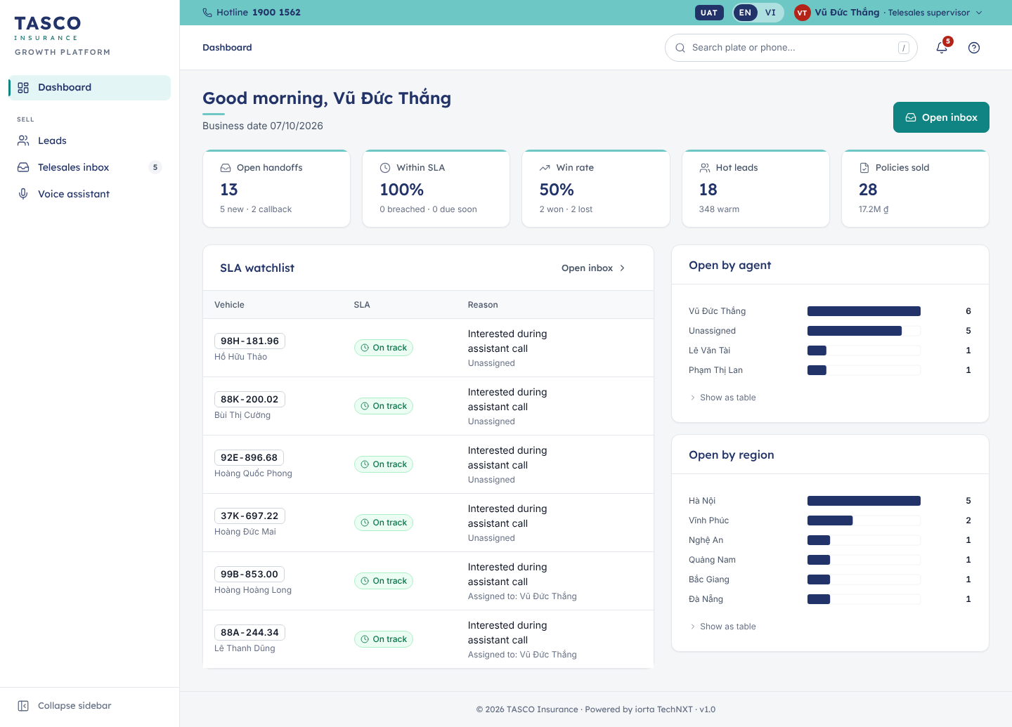
Figure 12 – Telesales supervisor dashboard

Manage the queue
- Select Telesales inbox (or Open inbox on the Dashboard).
- Use the status chips above the queue: New, In progress, Callback, Won, Lost. Each shows its count.
- Switch Only mine off to see the whole team’s work.
- The queue lists waiting work with the oldest deadline first. Each card shows the plate, customer, reason, SLA chip, assigned agent and age.
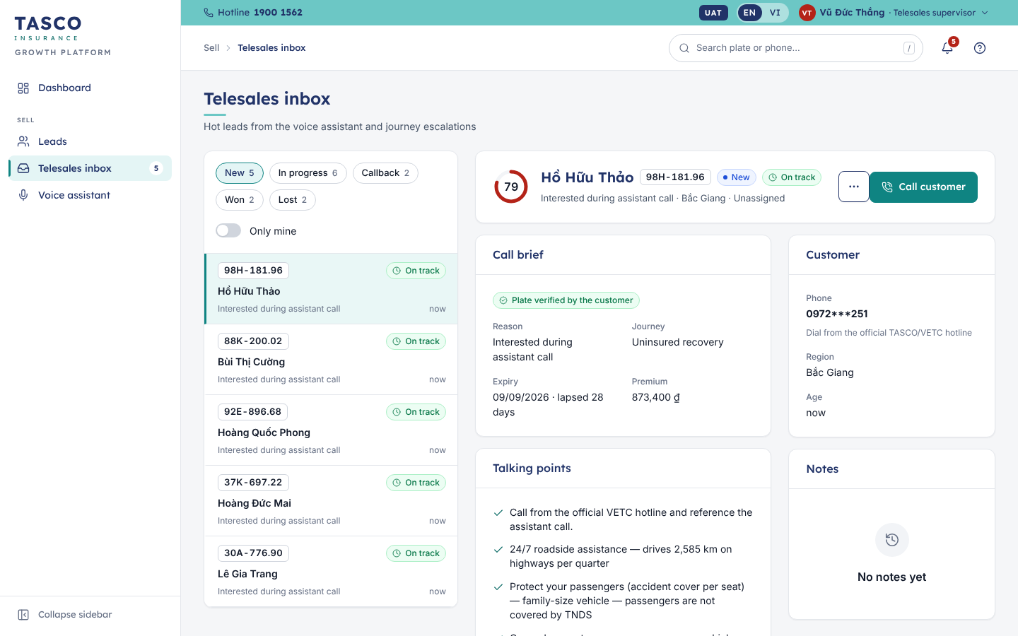
Figure 13 – Telesales inbox

Reassign a handoff
- Select the handoff in the queue.
- In the detail panel, open More actions and select Reassign.
- Choose the agent under Assign to. The list shows agents and supervisors with their region.
- Add a Note if useful, for example why the handoff moved.
- Select Reassign.
The handoff moves to the new agent, who sees it in their queue. The note is kept in the handoff’s Notes.
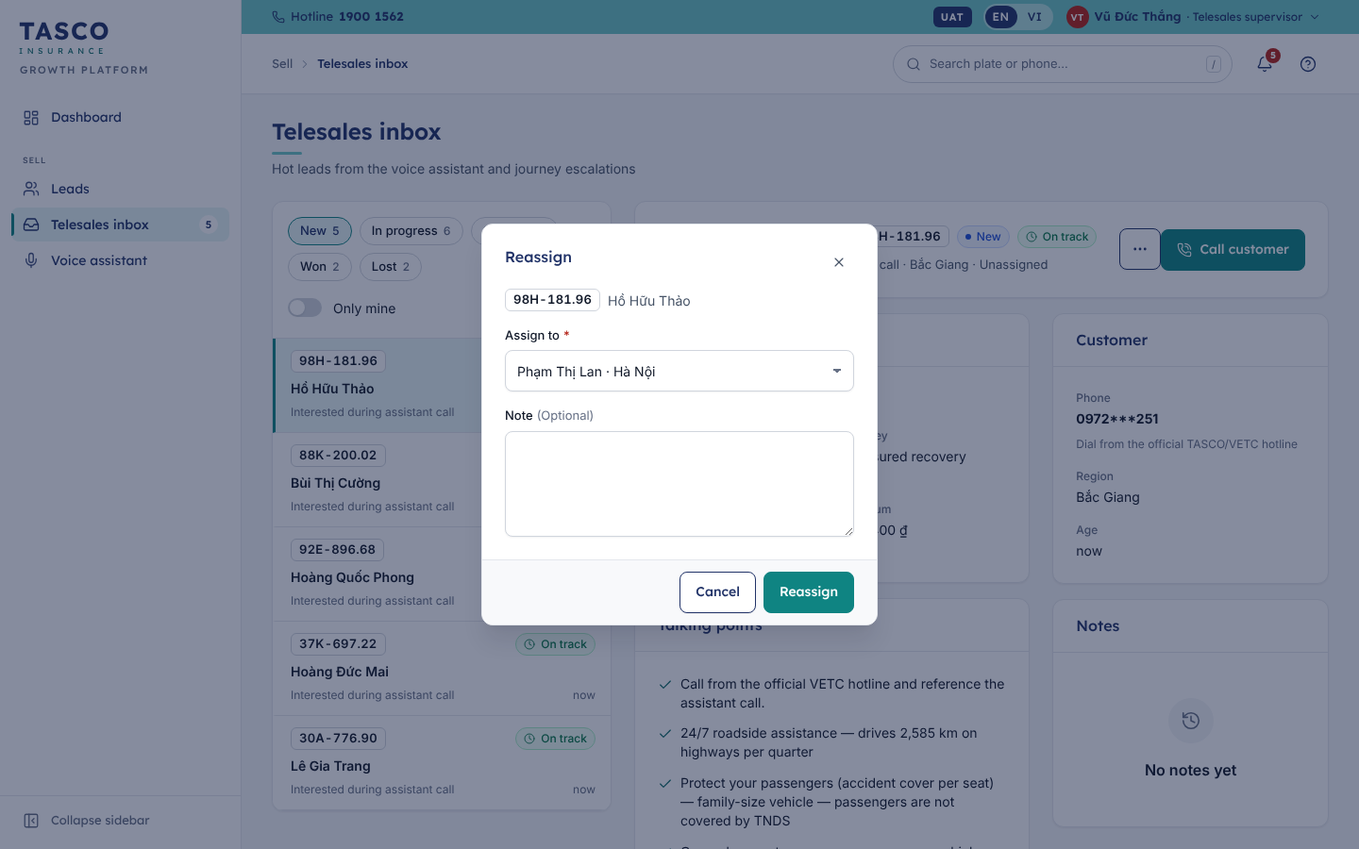
Figure 14 – Reassign a handoff

Correct an outcome
Won and lost are final. If an agent recorded the wrong outcome, add a note to the handoff explaining the correction with More actions › Add note, and tell the agent. Do not reopen work by creating duplicate quotes.

Coaching checklist
When you sample a handoff, check that the agent:
- called from the official hotline and referred to the assistant’s call;
- read the call brief and talking points first, especially a trust concern or a price question;
- answered price questions truthfully (regulated price, same at every insurer) and offered one relevant service benefit;
- sent the quote to the customer’s app and never asked for payment or OTP codes by phone;
- recorded the outcome and a clear note straight after the call.

What to check
- Breached handoffs on the watchlist: reassign or call yourself.
- An agent with many In progress handoffs and few outcomes.
- Lost reasons: many “Price / budget” outcomes suggest the value message needs work.

Telesales agent

What the role is for
The voice assistant makes the first call. It says that it is automated, checks the licence plate with the customer, confirms the expiry date and answers basic questions. When a customer is interested, or a customer has not responded to digital reminders, the platform puts a handoff in your Telesales inbox.
Your job is to call the customer, prepare a quote, send it to the customer’s app and record the outcome. You see customers and handoffs in your own region, with personal data.
Three promises are kept on every call: you call from the official TASCO or VETC hotline; you never ask for OTP codes, card details or payment by phone; you never offer a discount on TNDS.

Daily routine
- Start on My work today. It shows Handoffs to call, Callbacks, New in my region and Hot leads to work.
- Work the handoffs in the order the inbox shows them: the oldest deadline first.
- Make the callbacks you scheduled for today.
- Between handoffs, work the hot leads list.
- Record every outcome before you take the next call.
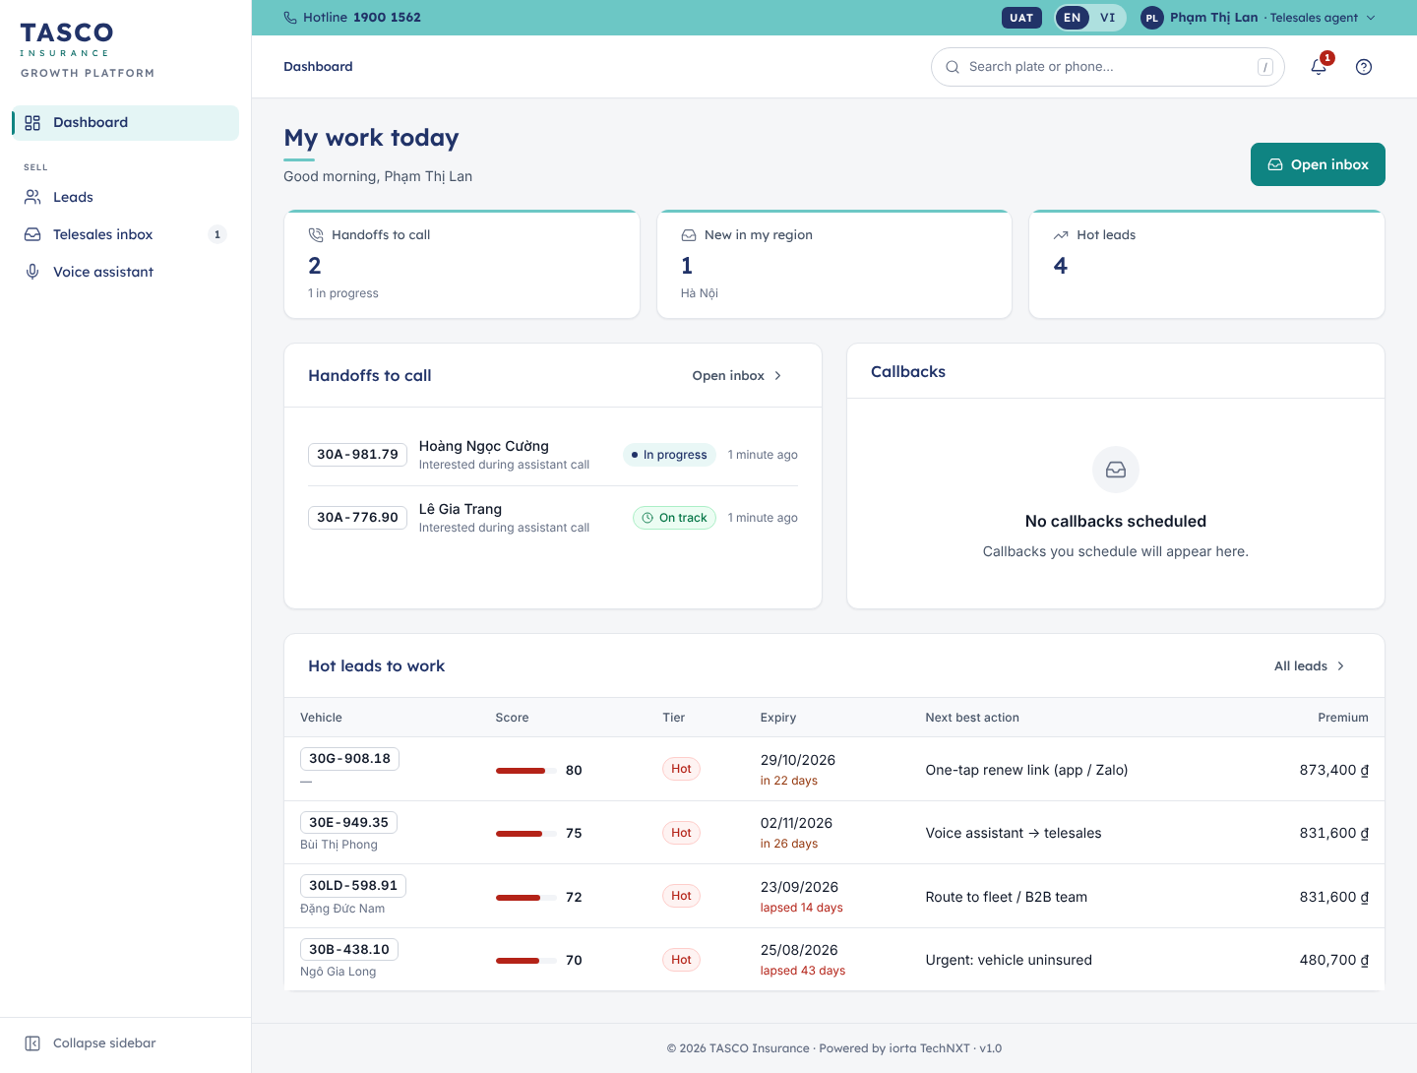
Figure 15 – My work today

Work a handoff

Open and read the call brief
- Select Telesales inbox in the sidebar, or a handoff on My work today.
- Select the first card in the queue. The detail panel opens next to the queue.
- Read the panel before you dial:
  - the header: customer name, plate, status, SLA chip, reason and region;
  - Call brief: signals such as Plate verified by the customer, Asked about price or Raised a trust concern, with the journey, expiry date and premium;
  - Talking points generated for this customer;
  - Customer: the masked phone number with the reminder “Dial from the official TASCO/VETC hotline”;
  - Notes from earlier contacts.
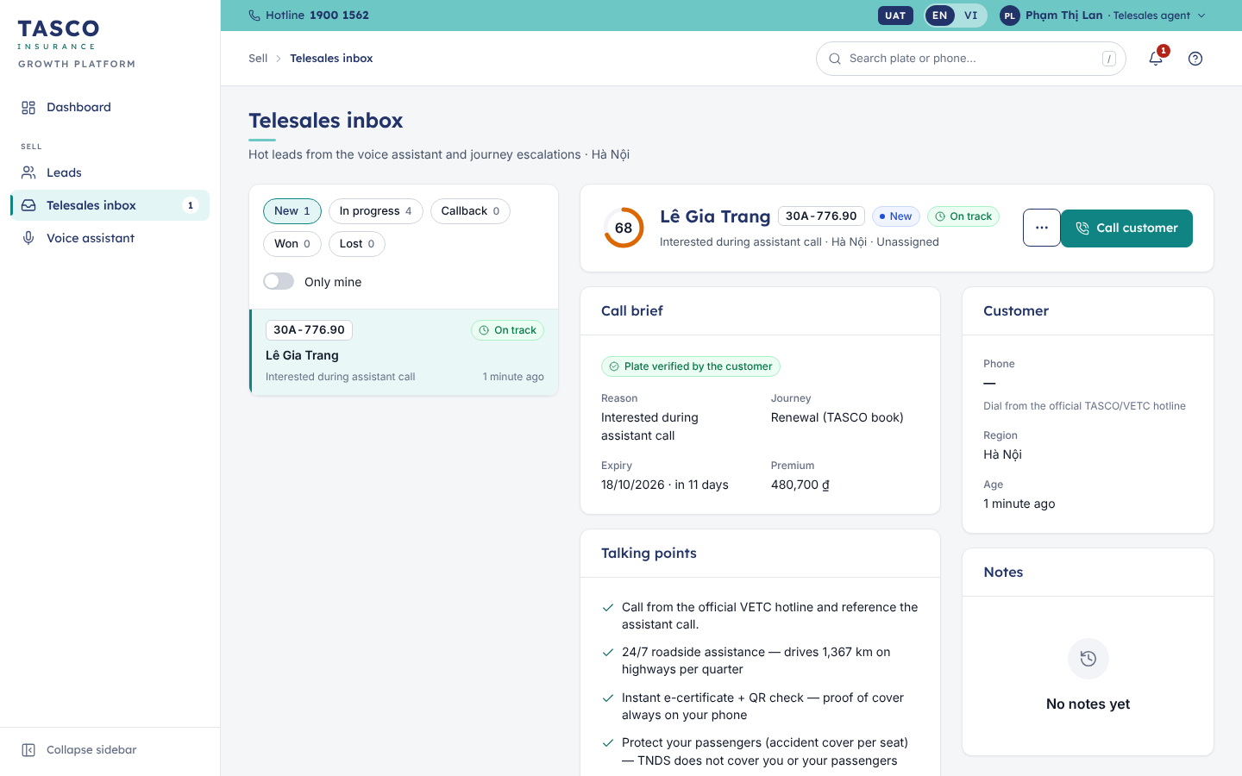
Figure 16 – Handoff detail and actions

Call
- Select Call customer. The status changes to In progress, the handoff is assigned to you and other agents no longer see it. The toast reminds you to call from the official hotline.
- Call the customer. Refer to the assistant’s call and confirm the plate.

Quote
- Select Send quote. Customer 360 opens on the Policy & quotes tab.
- In Build a quote:
  - Compulsory third-party liability (car) is always included and priced by regulation;
  - switch on Driver & passenger accident if the customer wants it, and choose the Cover per seat (VND 10, 20 or 50 million);
  - switch on Motor physical damage if the customer wants it, and enter the Vehicle value (sum insured), at least VND 100,000,000;
  - choose the Term: 1, 2 or 3 years.
- Select Calculate price. The Quote summary shows each product with its period, premium and VAT, the total and, when the products form a bundle, the bundle name. The line under the total says whether the price came from TASCO core or from TASCO’s filed rates.
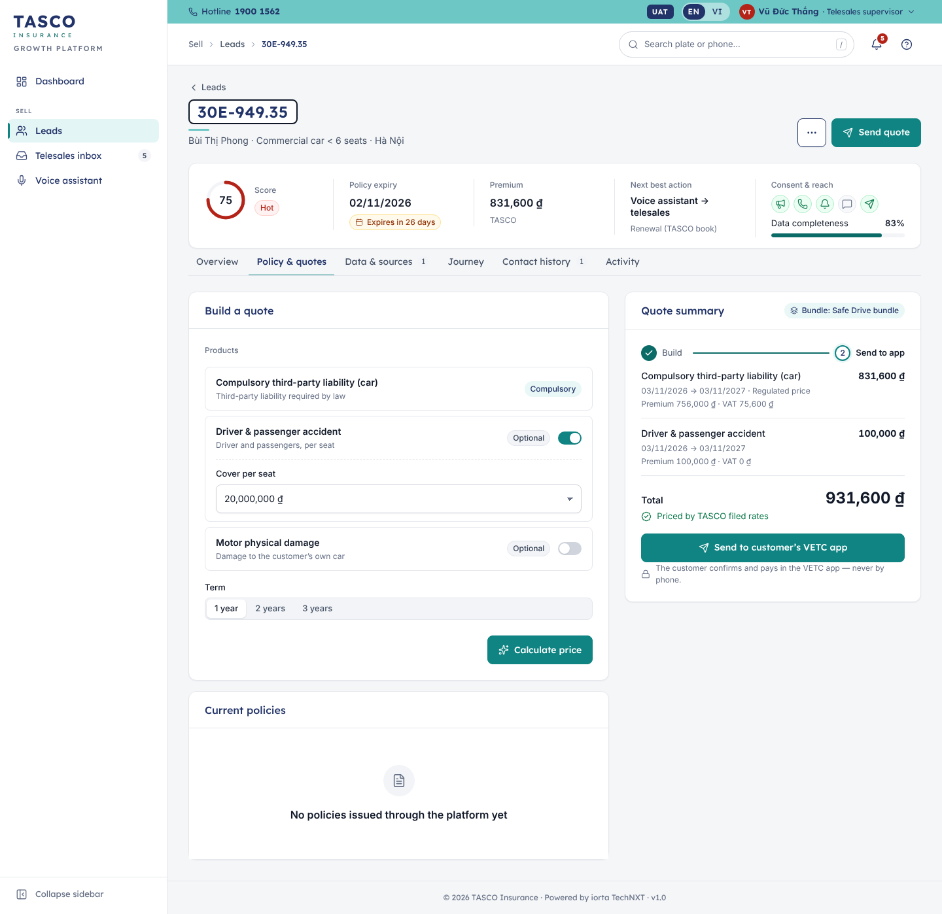
Figure 17 – Customer 360, policy and quote
If the summary shows Indicative price, TASCO core was not available. Select Re-rate before sending; an indicative quote cannot be paid.
If the quote includes physical damage cover, the summary shows a Vehicle inspection step. Select Record inspection, enter the Inspection evidence (assessor name and photo reference), tick Inspection passed and confirm. Sending stays disabled until the inspection is recorded.

Send the quote to the customer
- Select Send to customer’s VETC app.
The toast confirms “Quote sent to the customer’s VETC app”. The customer sees the quote on the home screen of the app and pays there. If no channel can reach the customer, the toast says “No channel available to reach this customer”; tell your supervisor.

Record the outcome
- Return to the Telesales inbox and select the handoff.
- Open More actions and choose:
  - Mark won when the customer agreed and will pay in the app. Describe it under What happened?.
  - Schedule callback when the customer asks you to call later. Set Call back on and the Time.
  - Mark lost with a Reason: Price / budget, Renewed with another insurer, Not interested, Could not reach the customer, or Other.
  - Add note for anything colleagues should know.
The handoff moves to the matching status chip and the note is saved with your name.

Customer 360
Customer 360 is one page about one vehicle and its owner. Open it from Leads, the inbox (View Customer 360) or the global search.
The header shows the plate, the owner, vehicle category and province, and a Do not contact badge and red banner if the customer opted out. The summary card shows the lead score ring and tier, the policy expiry with a status chip (for example “Expires in 22 days” or “Lapsed 25 days”), the premium and current insurer, the next best action and journey, and the consent and reach icons (marketing consent, call consent, VETC app notifications, Zalo, SMS) with a data completeness meter.
Tab | What it shows
Overview | Why this customer (each score factor with points and a reason), Guided next action, and Value to offer: the service benefits relevant to this customer. A benefit marked “Staff only · pending legal review” must not be offered.
Policy & quotes | The quote builder (roles that can quote) and Current policies with certificate numbers and periods
Data & sources | Golden record, Where the data comes from (each field with its source and confidence), Expiry evidence and Data-quality issues
Journey | The journey stepper and every touchpoint with its channel, date, status and, if skipped, the reason
Contact history | Messages and assistant calls; select a call to open its transcript
Activity | Who viewed or changed the record, customer actions in the app and policies issued
More actions in the header offers Start assistant call (opens a rehearsal with the voice assistant for this customer), Open in telesales inbox and, for roles allowed to, Correct expiry date and Simulate wallet top-up.
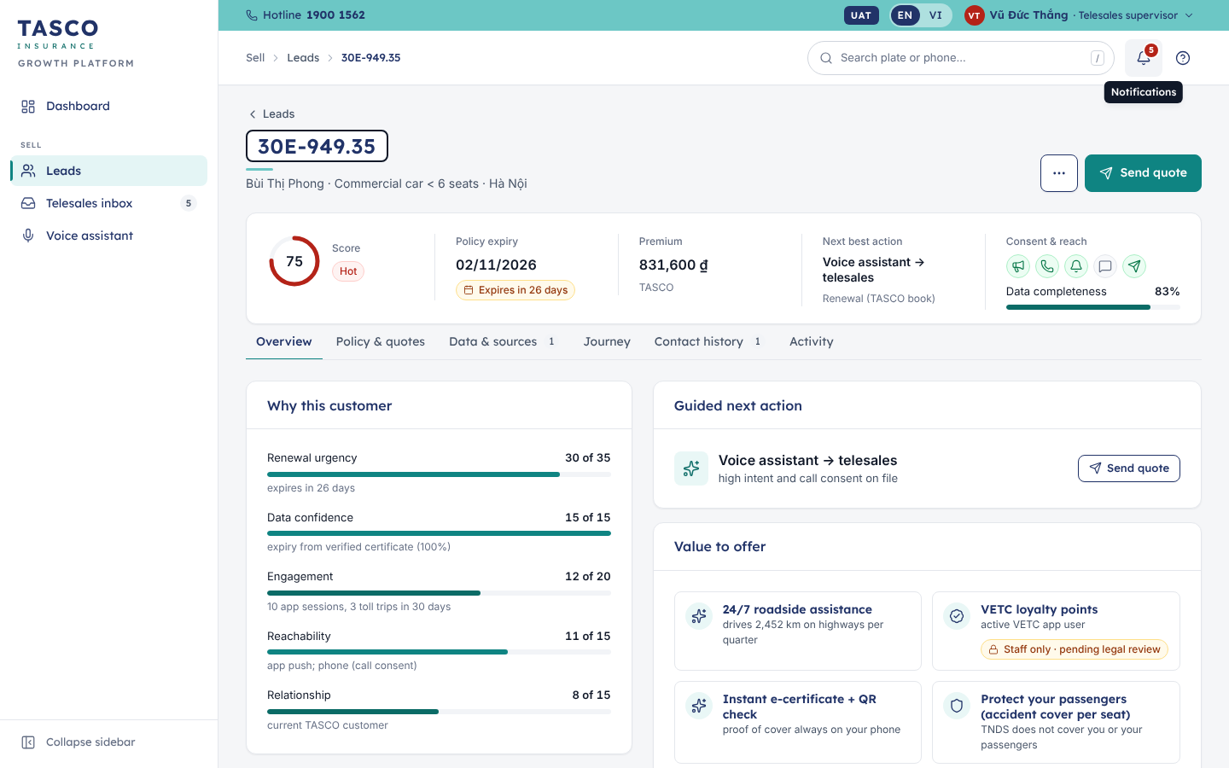
Figure 18 – Customer 360 overview

Rehearse a call
To hear what the voice assistant says before calling a customer, select Voice assistant › Rehearse a call and pick a customer, or use Start assistant call in Customer 360. Type what the customer would say, or use the Quick replies. The stepper shows the stage (Introduction, Plate check, Offer, Wrap-up). Rehearsals are recorded like real calls; in production, rehearse only with customers you are working on.

Handling common objections
The customer says | Do | Do not
“Is this a scam? How do you have my number?” | Explain that you call the VETC account holder who registered this number, that TASCO never asks for OTP or payment by phone, and offer to send the quote to their app so they can check it there. | Push for the sale
“Can you make it cheaper?” | Explain that the TNDS price is set by regulation and is the same everywhere, then mention one service benefit that fits the customer. | Promise a discount, gift or cashback
“I already renewed.” | Thank them; ask which insurer and the new expiry date; record Mark lost with “Renewed with another insurer”. | Argue
“Call me later.” | Agree a time; record Schedule callback. | Call outside 08:00 to 20:00
“Don’t call me again.” | Apologise and end the call; record Mark lost with a note and tell your supervisor. The customer can also turn off calls in the app. | Continue the call
“Wrong person” or “I sold the car.” | Apologise and end the call; record Mark lost with a note. | Reveal any vehicle or policy details

What to check
- The SLA chip on your oldest New handoff.
- That every handoff you called has an outcome before you take the next one.
- Your callbacks for today.

Rule author and approver

What the role is for
Business rules decide how the platform behaves: lead scoring, next best actions, journeys and cadences, message and voice script wording, the contact policy, benefits, commission, data trust and service levels. Rules are versioned and every change follows maker-checker: a rule author drafts it and a different person approves it. Nobody can approve their own change, and one person cannot hold both roles.
Five rule sets are restricted and can only be approved by a compliance officer: Contact policy, Copy guard, Access policies, Partner commission and Data retention.
Pricing rules (the TNDS tariffs and the physical damage and seat accident rates) are owned by TASCO core when the platform rates through TASCO core. They then show the banner “Owned by TASCO core” and cannot be edited. The product catalogue is kept in line with TASCO core by a nightly sync that proposes changes for approval.

Daily routine
- Rule author: check the status of your drafts and submitted changes on Business rules; read any rejection reason and respond.
- Rule approver: open Approvals when the badge shows changes waiting for you; decide each one the same day where possible.

Find a rule set
- Select Business rules in the sidebar. Rule sets are grouped by area: Selling, Contact & messaging, Products & pricing, Partners, Data, Access & compliance.
- Each row shows the rule set’s business name and purpose, its versions as chips (for example “Active v1 · Awaiting approval v2 · Draft v3”), who changed it last and when, and who approves it (Rule approver or Compliance).
- Use the search box or the chips All, Awaiting approval, Drafts and Restricted to narrow the list. The tiles at the top do the same.
- Select a row to open the version that needs attention: a pending one first, then the newest draft, then the active one.
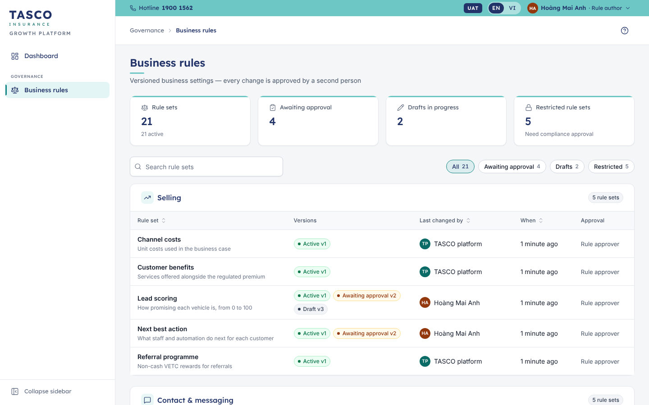
Figure 19 – Business rules

Author a change
- Open the rule set and select Create draft from this version on the active version. A new draft opens; if you already have one, Open my draft takes you to it.
- Edit the settings in the form. Each rule set has its own form, with sliders and number fields for weights and thresholds, tables for decision rules, switches for flags and text fields for message wording. One-line help sits under each field.
- Watch What changes on the right. It lists every difference from the active version in business words, for example “Hot lead threshold: 70 → 68”.
- Select Validate. Problems are explained next to the field in plain language. For message and script wording, the copy guard checks for banned phrases such as discount claims. “All checks passed” means the draft can be submitted.
- Select Save draft. A badge reads Unsaved changes until you do.
Technical users (administrators and support engineers) also see Advanced (JSON), a technical view of the same settings. Business users do not need it.

Simulate before you submit
For lead scoring, next best action, journeys and benefits, the Simulation panel shows the effect of your draft on real customers.
- Under Find a customer, type part of a plate (for example 30E949) or pick one of the suggested customers.
- Select Run simulation. The comparison shows score, tier and next best action before and after the change.
- Select Test on 60 customers to see the effect on a sample across all tiers: how many customers change tier, and the movements between tiers and next best actions.
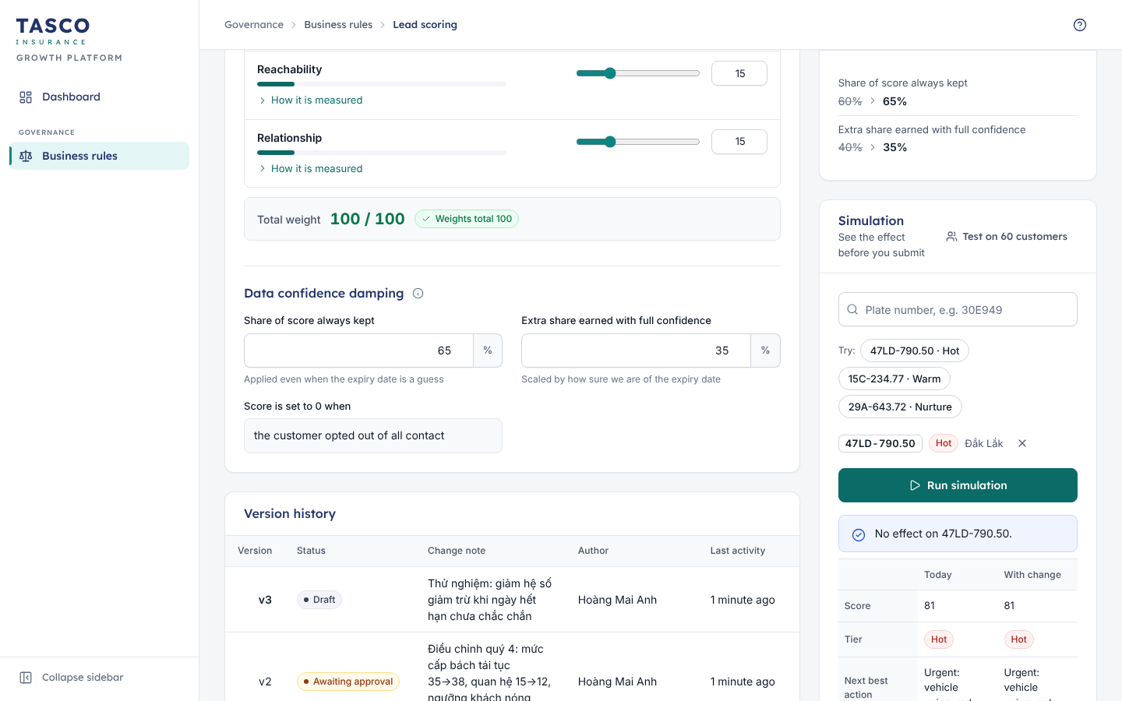
Figure 20 – Simulation of a lead scoring change

Submit for approval
- Select Submit for approval. The draft is validated again.
- Under Note for the approver, explain what changes and why, for example the simulation result. The note is required.
- Select Submit for approval in the dialog.
The workflow stepper moves from Draft to Awaiting approval, and the approvers see the change in their inbox. While it waits, you can select Withdraw to take it back to draft and edit it. You cannot approve your own change.
If the change is rejected, the version shows a red banner with the approver’s reason. Select Create draft from this version to start a corrected draft.

Roll back
Open an earlier version (status Replaced) from Version history and select Roll back to this version. This creates a draft with the earlier settings, which goes through approval like any other change.

Review and approve a change
- Select Approvals in the sidebar. The tiles show Waiting for you, Oldest request, Need compliance approval and Decided in 30 days.
- The Inbox tab lists each change with the rule set and version, Requested by, Submitted, the Author’s note and the approver needed. Select Review.
- The review drawer shows:
  - a banner about who may decide. “You cannot approve your own change” or “Compliance approval required” appear when you may not decide; otherwise the banner reminds you that approval activates the version at once;
  - what the version replaces and the author’s note;
  - What changes, in business words;
  - Effect on customers, simulated on a sample of about 60 customers (scoring, next best action, journeys and benefits);
  - Check a specific customer for a single before-and-after comparison.
- To approve, select Approve, add an optional Approval note and select Approve and activate. The new version is active immediately for all customers and replaces the previous one.
- To reject, select Reject…, give the Reason for rejection (what must change before it can be approved) and select Reject change. The change goes back to the author with your reason.
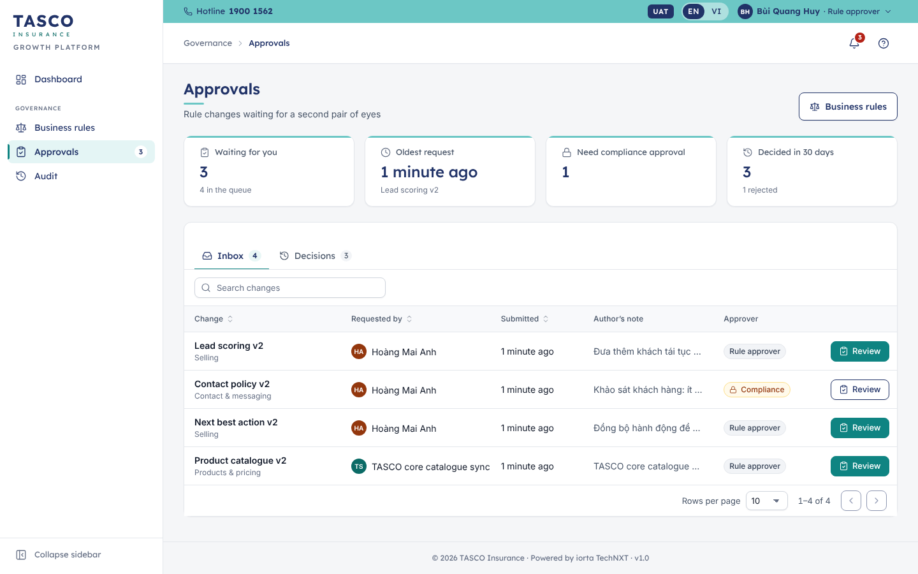
Figure 21 – Approvals inbox
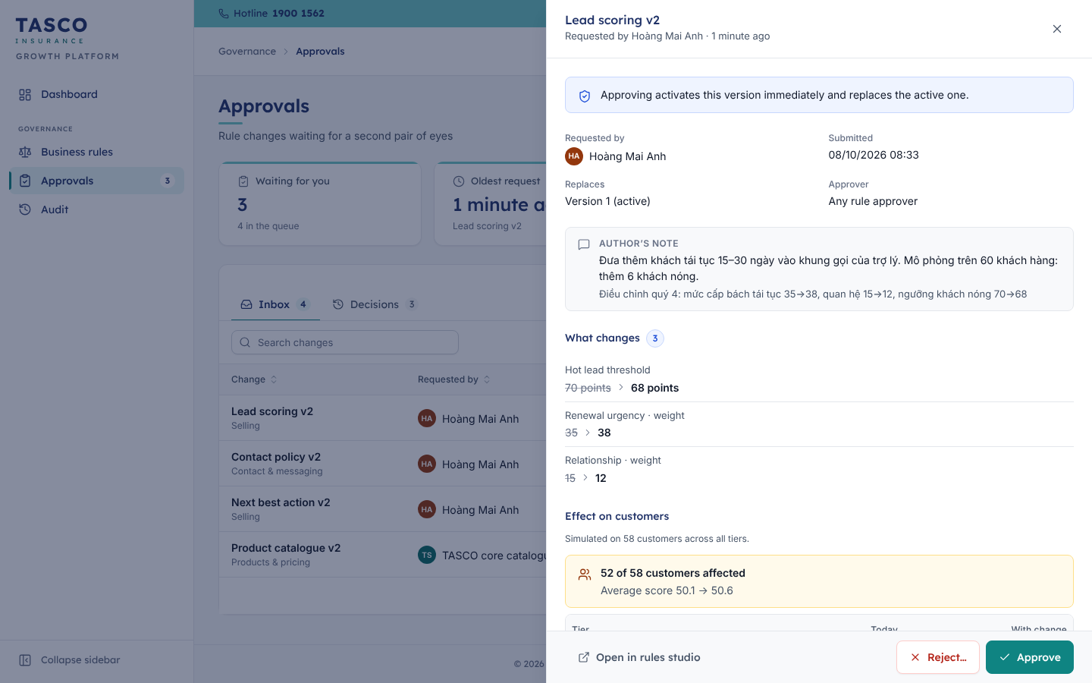
Figure 22 – Reviewing a change
The Decisions tab lists past decisions with the decision, who decided, who requested it, when, the comment and the rule set’s current status. Export CSV gives the list for governance reporting.

What to check
- As author: run the simulation and put its result in the note; approvers reject changes without evidence.
- As approver: that the note explains the change, that What changes matches the note, and that the effect on customers is what the author expects.
- Message and voice wording: no discount language, the automated-call disclosure kept, plain Vietnamese.

Compliance officer

What the role is for
The compliance officer approves the restricted rule sets, watches the voice assistant’s compliance figures and reviews the audit trail. The role can open Customer 360 with personal data masked. Two-step verification is required.

Daily routine
- Open Approvals when the bell or badge shows changes waiting. Restricted changes show the Compliance chip.
- Once a week, review the Audit page: voice compliance figures and changes to rules and users.
- Once a month, complete the checklist under “What to check” below.

Approve a restricted change
The steps are the same as for any rule approver (see “Review and approve a change” in the Rule author and approver chapter). Restricted rule sets are those where a mistake has legal or regulatory effect:
Rule set | What to look for
Contact policy | Contact hours (08:00 to 20:00), daily and weekly limits, consent needed per channel, which service notices may ignore marketing limits
Copy guard | Banned phrases in customer wording, such as discount, rebate or cashback claims on TNDS
Access policies | Who may see which customer records (region limits)
Partner commission | Rates within the statutory caps
Data retention | How long each kind of record is kept
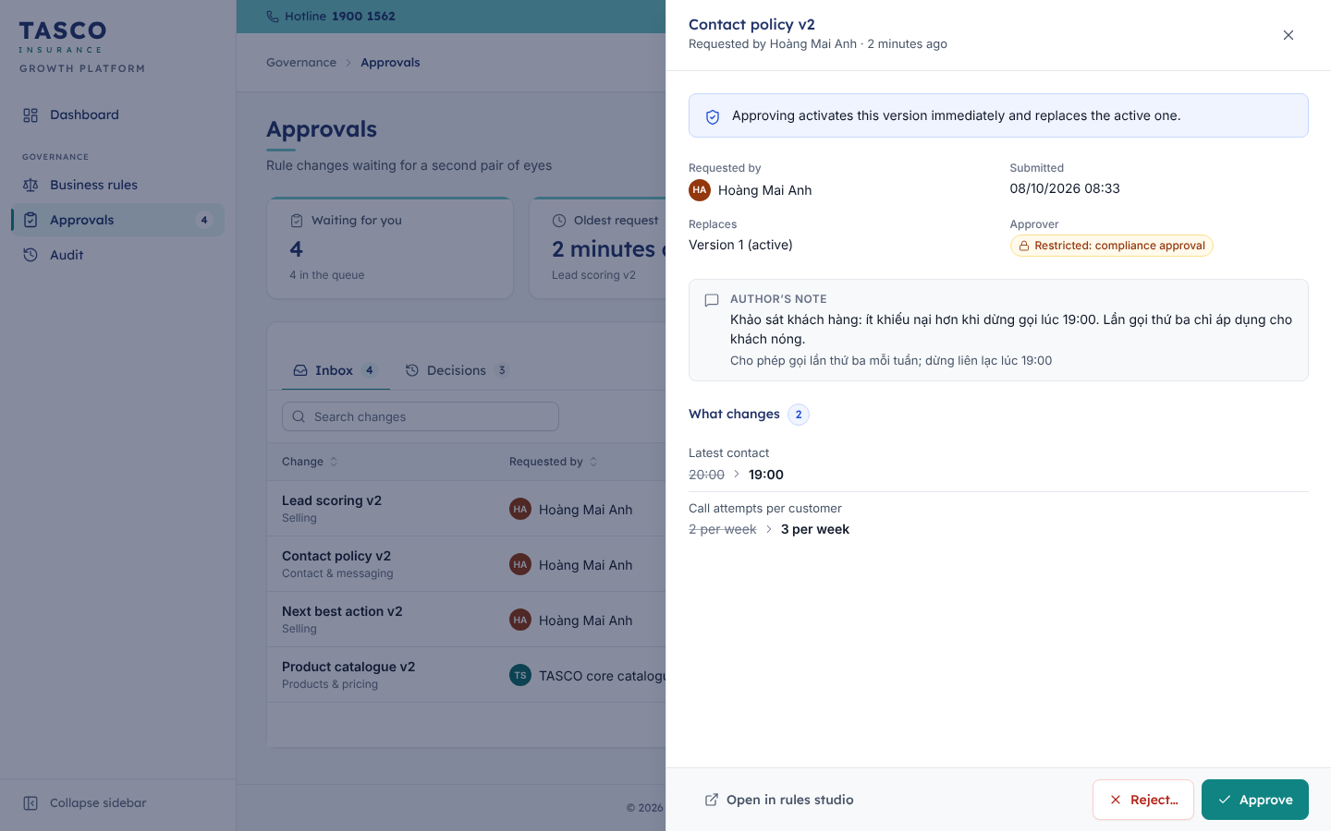
Figure 23 – Reviewing a restricted contact policy change

Review voice assistant compliance
The Audit page opens with an integrity banner and a strip of voice compliance figures:
Figure | What it means
Voice assistant calls | Calls made in the period
Disclosed as automated | Share of calls where the assistant announced it is automated at the start (always 100%)
Opt-out rate | Customers who asked not to be called
Plate verification failures | Calls ended before any offer because the plate did not match
Scam concerns raised | Customers who raised a scam concern; the assistant handles these with the trust script

Search the audit trail
- Select Audit in the sidebar.
- Narrow the list with Person (or TASCO platform (automated)), Activity type (Sign-in & access, Customer data, Sales, Rules, Claims, Partners, Administration), Object and the date range.
- Search for a word, a person or an object in the search box.
- Select a row to open the record. It shows when, the activity type, the person and role, the object (with a link where your role may open it) and a Before and after table for changes.
- Select Export CSV to keep the result as evidence.
Each row is a plain sentence, for example “Rule Author submitted Lead scoring v3 for approval”. The page shows the latest 500 matching records; narrow the dates to see older activity.
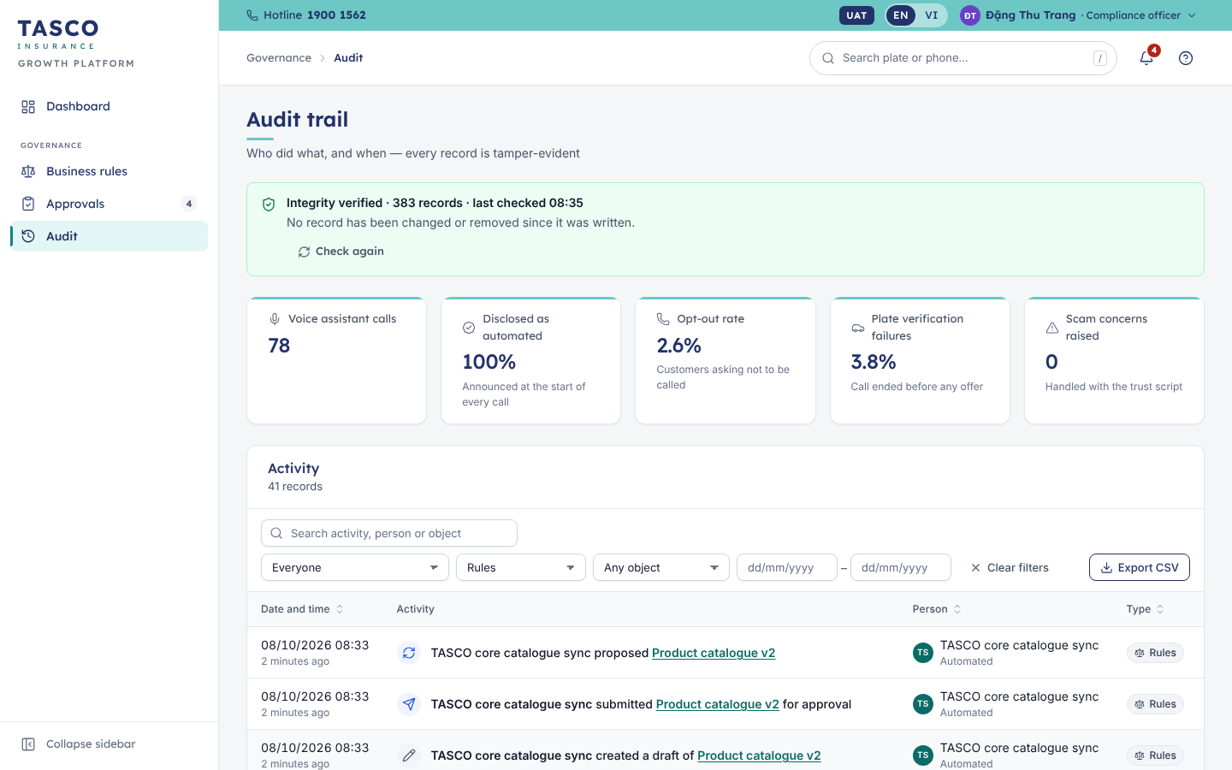
Figure 24 – Audit trail filtered to rule changes
The integrity banner reads “Integrity verified” with the number of records and the time of the last check. Check again re-checks the whole chain. If it ever reads “Integrity check failed”, escalate at once to Security and Internal Audit.

Data subject requests
There is no console screen for data subject access or erasure requests in this release. Customers can download their own data from the Account tab of the customer app (see TGP-MAN-02 Customer App Guide). For any other request, the compliance officer raises it with TASCO IT, who run the export or erasure; each one is recorded in the audit trail as “exported the personal data of…” or “erased the personal data of…”. The procedure is to be confirmed by TASCO legal.

What to check
Monthly checklist:
- Every restricted change approved in the month has a clear author’s note and simulation evidence where it applies.
- Opt-out rate and scam concerns: investigate any rise with the campaign manager.
- No rule set approved by the same person who authored it (the console prevents this; the audit trail confirms it).
- Sign-in activity: repeated lockouts or sign-ins at unusual hours.
- Integrity banner shows “Integrity verified”.

Data steward

What the role is for
The platform keeps one trusted record per vehicle (the golden record), built from VETC accounts, TASCO core, partner files, customer declarations and assistant calls. Each fact carries its source and a confidence level. When sources disagree or a fact is missing, the platform raises a data issue. The data steward works the Data quality queue so that sales and journeys run on reliable data. Two-step verification is required.

Daily routine
- Open Data quality. Check the Open issues and High severity tiles.
- Assign today’s work: select issues and Assign, or take them with Assign to me.
- Resolve high-severity issues first: unreliable expiry dates, customers who say they renewed elsewhere, conflicting phone numbers and plate mismatches from calls.
- Dismiss issues that need no action, with a reason.

Read the queue
The type chips above the queue show each issue type with its count, for example Unreliable expiry date or Missing phone; select one to filter. Each row shows:
Column | Content
Issue | The issue type and its severity chip (High, Medium or Low)
Vehicle | Plate and owner (masked where required)
Source | Where the record came from and when, for example “VETC account import · 07/10/2026”
Age | How long the issue has been open
Assignee | Who is working it, or Unassigned
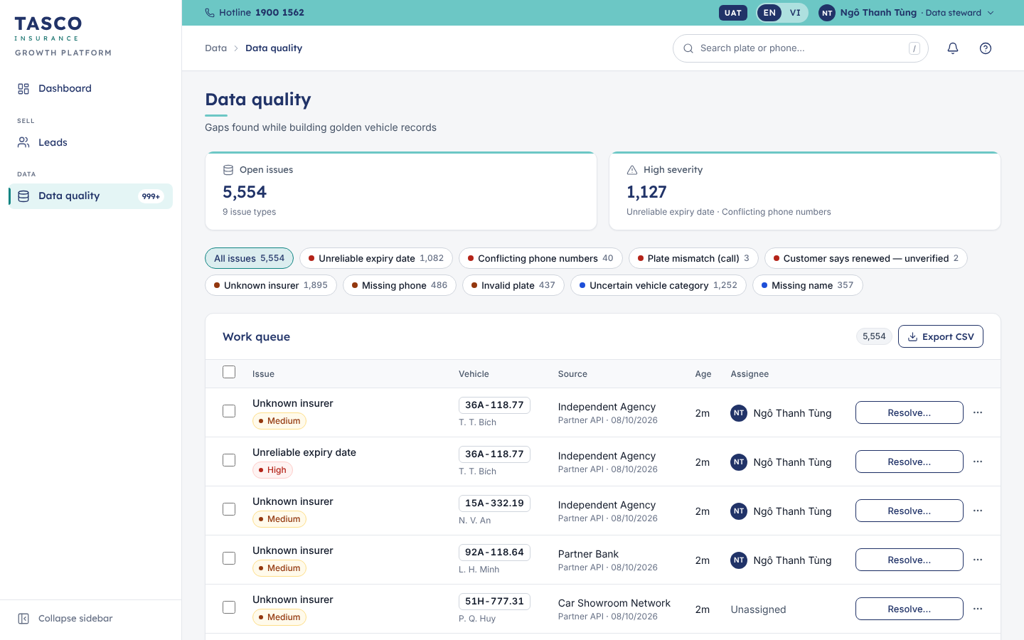
Figure 25 – Data quality queue

Resolve an issue
- Select Resolve… on the row. The drawer opens with the issue, the current values, the data lineage and, for conflicts, Two sources disagree side by side.
- Under Resolution, choose how to resolve it. The options depend on the issue type:
  - Confirm current value: the value on record is correct; nothing changes.
  - Correct with evidence: enter the correct value (expiry date and insurer, vehicle type, phone, name or plate).
  - Merge duplicates: choose the Phone number to keep; the others are retired.
  - Keep the verified record or Accept the customer’s statement when a customer says they renewed elsewhere.
  - Dismiss with a reason.
- Choose the Evidence type (photo of the certificate, confirmation from the insurer, verification call with the owner, inspection record, vehicle registration or TASCO core lookup) and add an Evidence reference such as a certificate number or call reference.
- Select Resolve issue.
The issue closes, the golden record is updated, the lead is re-scored and the decision is recorded in the audit trail. Open Customer 360 in the drawer shows the whole record.
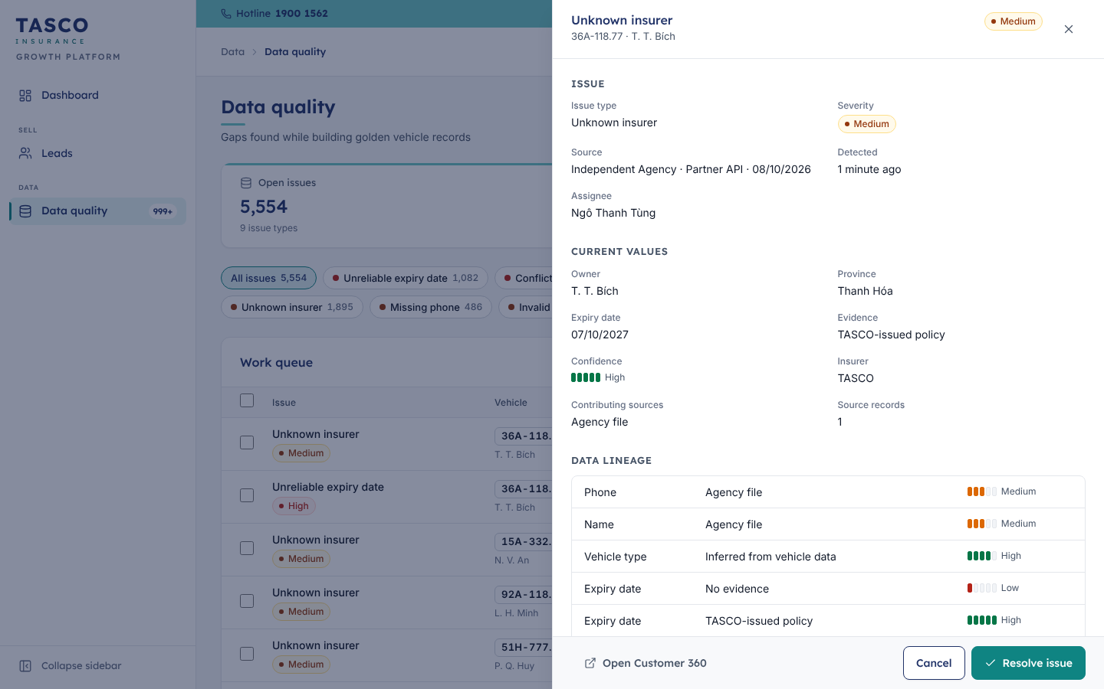
Figure 26 – Resolving a data issue

Assign or dismiss several issues
- Tick the rows, or the box in the header to select the page.
- Select Assign and choose a colleague, or Dismiss and choose a Reason: False positive, Duplicate of another issue, Vehicle sold or deregistered, Company vehicle handled by the fleet team, or Other reason. Add a Note if useful.
- Review and confirm.
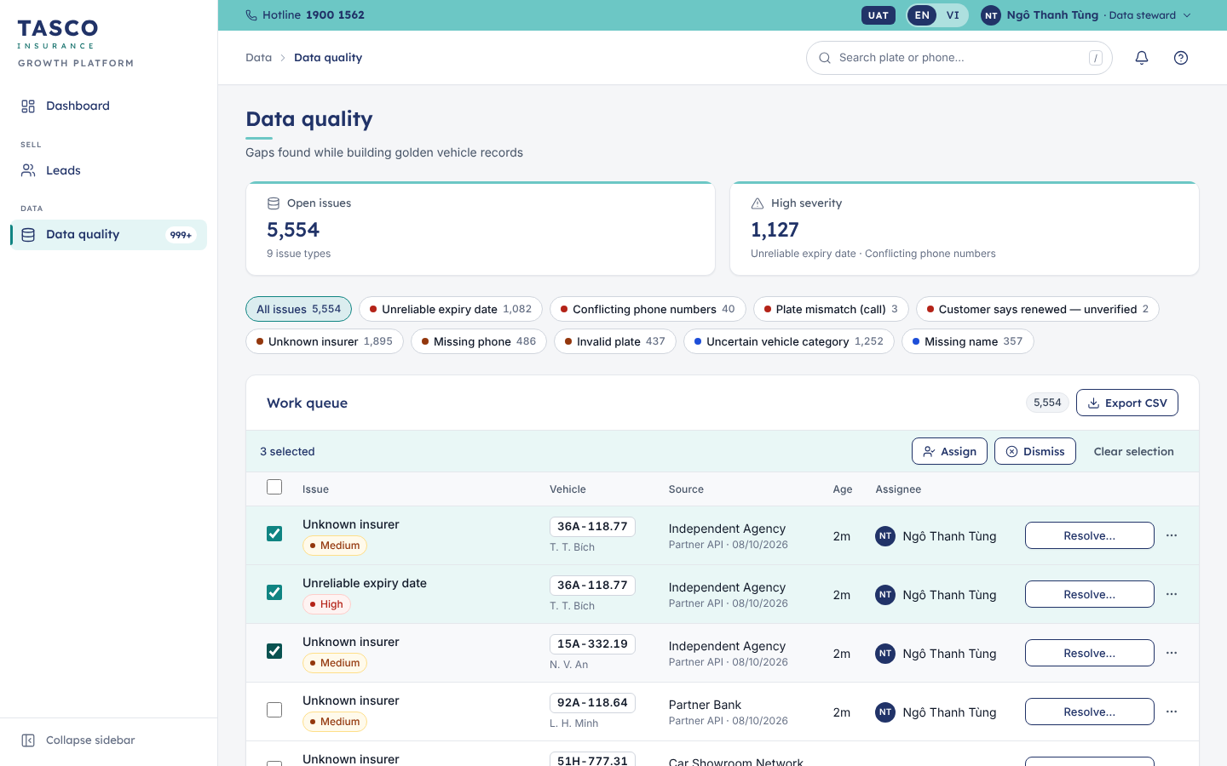
Figure 27 – Bulk actions on the data quality queue

Correct an expiry date from Customer 360
When a customer sends a certificate photo outside the queue, open the customer, select More actions › Correct expiry date, enter the New expiry date, the Current insurer if known and the Evidence (for example “certificate photo sent by the customer”), then Save correction. The lead is re-scored at once.

Data loads
Data from VETC, TASCO core and partner files is loaded through the platform’s integrations, not through the console. Each load appears in the audit trail (“imported 1,250 records from VETC account import”) and its rejected records appear as issues in the queue.

What to check
- High-severity issues older than two days.
- On the Dashboard, Data repair progress: the share of vehicles with a reliable expiry date should rise week by week.
- A sudden rise in one issue type after a data load: tell TASCO IT, as the source file may be faulty.

Claims handler

What the role is for
Customers report accidents in the customer app. Each report arrives in the Claims queue. The claims handler acknowledges it, assigns an assessor, records the assessment decision and the payment. The customer follows the progress in the app.
Service levels: acknowledge within 4 hours of the report, decide within 5 days and pay within 3 days of approval.

Daily routine
- Open Claims (your start page). Check the Due soon and SLA breached tiles; the bell also warns you two hours before an acknowledgement is due.
- Acknowledge every new claim in the To acknowledge view.
- Move each claim in assessment to its next step.
- Record payments for approved claims.

Read the queue
The tiles show Open claims (with the number awaiting acknowledgement), Due soon, SLA breached and Paid this month. The chips All, To acknowledge, In assessment, Awaiting payment and Closed filter the queue.
Each row shows the claim reference, the vehicle and owner, the incident date and product, a summary, the status chip with its SLA chip, and the Next step button.
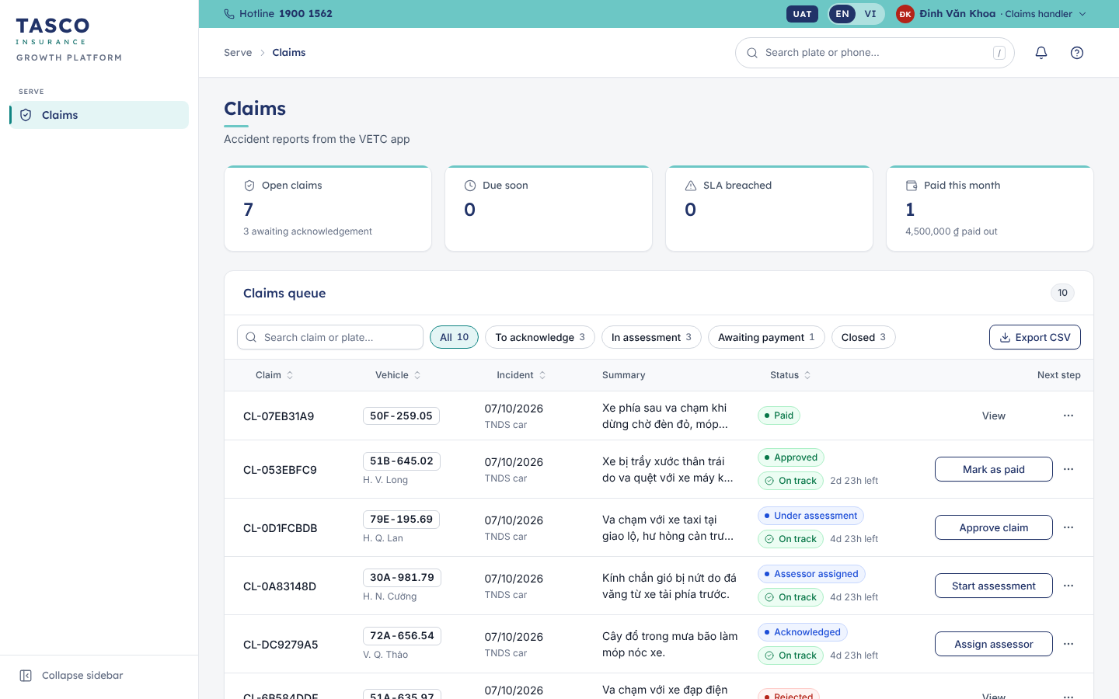
Figure 28 – Claims queue

Move a claim through its steps
The Next step button always names the next action:
Status | Next step | What you enter
Submitted | Acknowledge | Nothing; the customer is told the claim was received
Acknowledged | Assign assessor | Assessor full name, optional note
Assessor assigned | Start assessment | Nothing
Under assessment | Approve claim | Approved amount (₫) after deductible, optional note
Approved | Mark as paid | Payment reference (bank transfer or VETC wallet transaction), optional note
Paid or Rejected | View | Read-only
- Select the Next step button on the row, or open the claim and use the button at the foot of the drawer.
- If the step needs details, fill them in and select Review, then check the summary.
- Confirm, for example with Acknowledge or Confirm approval.
The status chip changes, the toast confirms the step and the customer sees the new stage in the app.
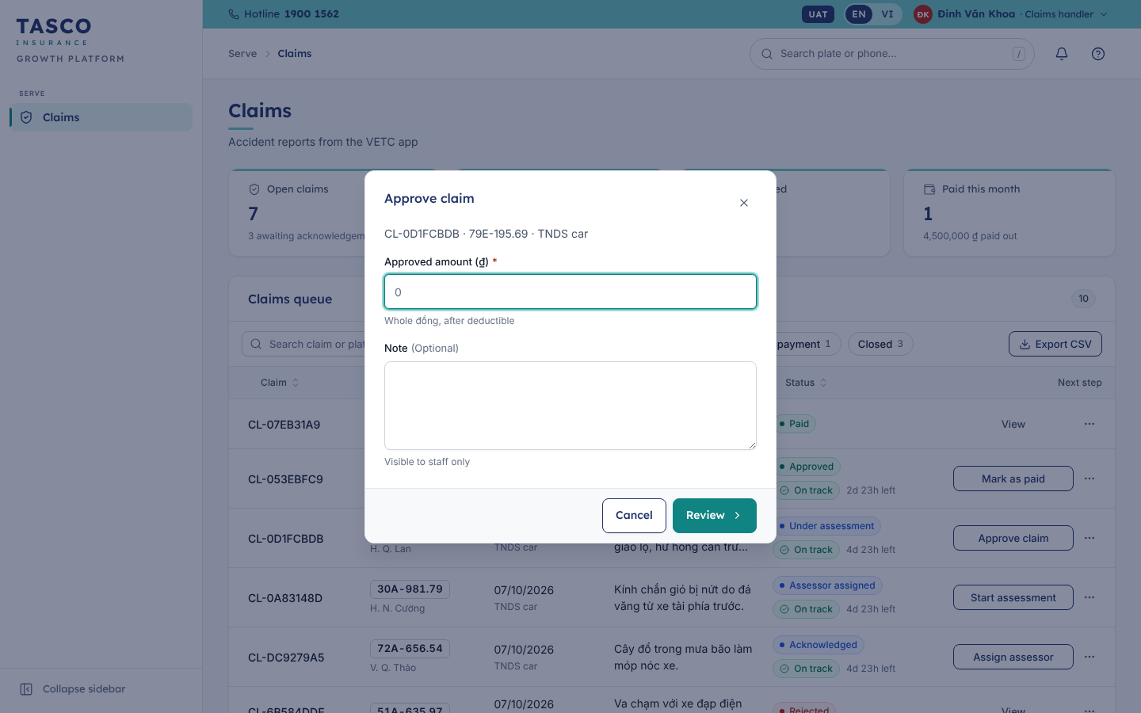
Figure 29 – Approving a claim

Reject a claim
A claim can be rejected while it is submitted, acknowledged or under assessment.
- Select Reject claim in More actions, or at the foot of the claim drawer.
- Choose the Rejection reason: Not covered by the policy, Outside the policy period, Missing documents, Suspected fraud, Duplicate of an existing claim, or Other reason.
- Write the Explanation for the customer (at least 10 characters).
- Review and select Confirm rejection.

Read a claim
Select a row to open the claim drawer.
Tab | Content
Overview | Progress (each step with who did it and when, the assessor, approved amount and payment reference), What happened (full description, incident date, location, report time, current SLA) and Photos sent from the app
Policy & customer | Product, certificate and policy numbers, policy period, premium and sales channel; plate, owner, province, vehicle type and owner type
Notes | Internal notes, visible to staff only. Add note to keep colleagues informed.
History | Every status change and note in time order
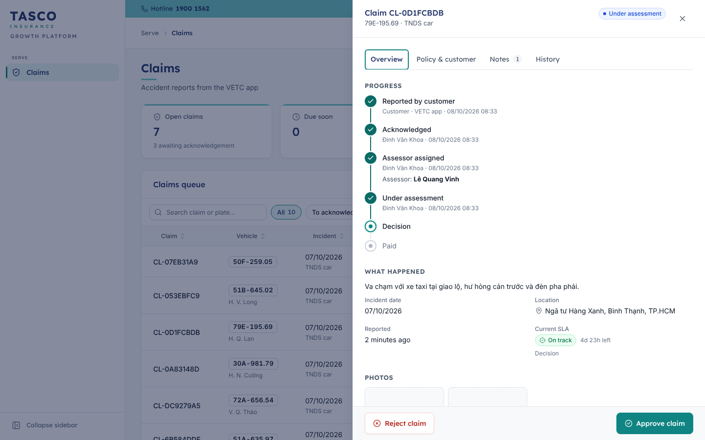
Figure 30 – Claim under assessment

What to check
- Nothing in SLA breached.
- The approved amount matches the assessor’s report before you confirm.
- Rejections always carry a clear explanation for the customer.

Partner manager

What the role is for
Partners such as banks, car showrooms, insurance agents, fleets and inspection centres sell TASCO cover through the Partner API. The partner manager onboards partners, issues and revokes their API keys, suspends or reactivates them and provides commission statements. The technical integration is described in TGP-MAN-03 Partner API Integration Guide. TASCO’s own Tasco360 partner app can connect as an API consumer in the same way.

Daily routine
- Open Partners. Check Active partners, Policies this month, Commission this month and Active API keys.
- Answer partner requests: new keys, statements, suspensions.
- Each month, send or confirm commission statements.
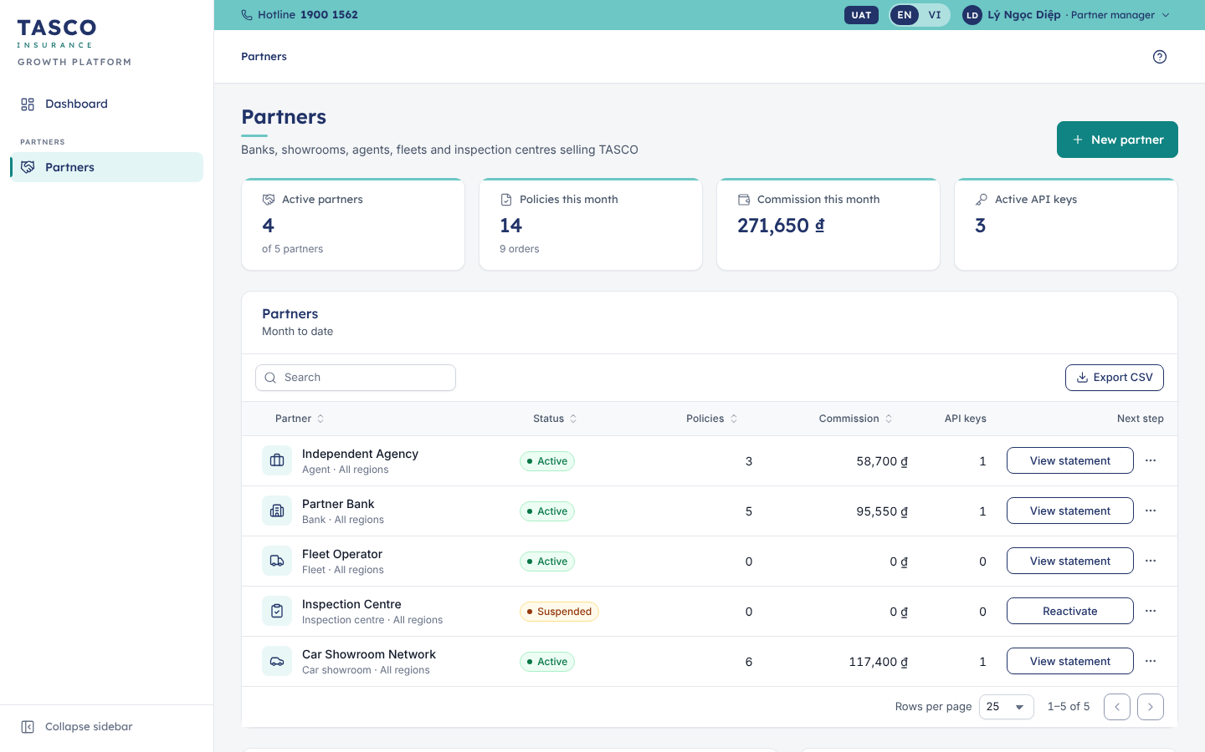
Figure 31 – Partners

Onboard a partner
- Select New partner.
- Enter the Partner name (legal or trading name), the Partner type and the Operating region.
- Tick Issue an API key after creating if the partner is ready to connect.
- Select Create partner.

Issue an API key
- On the partner’s row, open More actions › Issue API key (active partners only).
- Under Access, choose what the key may do: Quote, Purchase (create orders) and Read policies & statement.
- Choose the Key lifetime: 90 days, 180 days, 1 year or 2 years.
- Select Issue key.
- The New API key dialog shows the key once. Copy it, select I have copied the key, and send it to the partner over a secure channel.
TASCO stores only a fingerprint of the key, so a lost key cannot be shown again: issue a new one and revoke the old. Issue separate keys for the sandbox and for production.
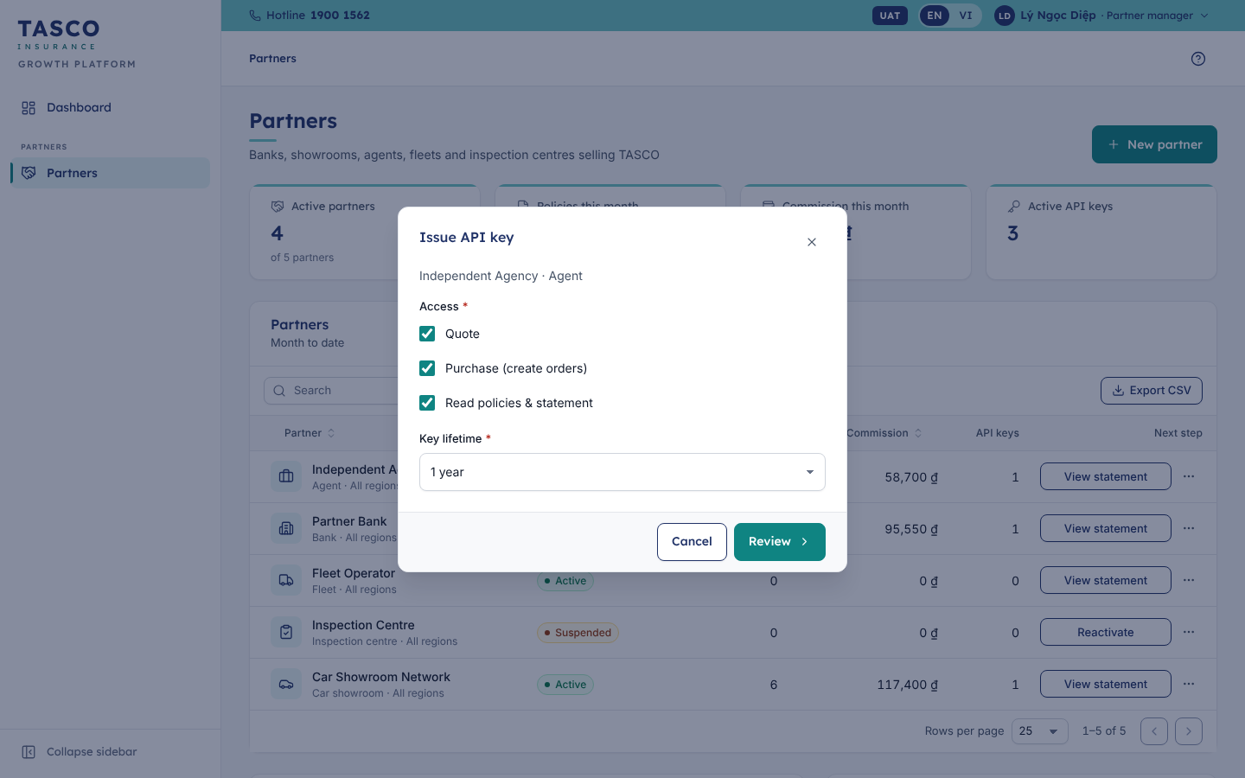
Figure 32 – Issue an API key

Revoke a key, suspend or reactivate a partner
- To revoke a key, open More actions › Manage API keys, find the key by its identifier and select Revoke. Systems using it are refused immediately.
- To stop a partner trading, select More actions › Suspend. The partner cannot quote or create orders until you select Reactivate.

Commission statements
- Select View statement on the partner’s row.
- Choose the period: This month, Last month, This quarter or Year to date.
- The statement shows Orders, Policies, Premium collected and the commission per order and product, with the rate, subtotal and total.
- Select Export CSV to send it to the partner or finance.
Partners can fetch the same statement themselves through the API.
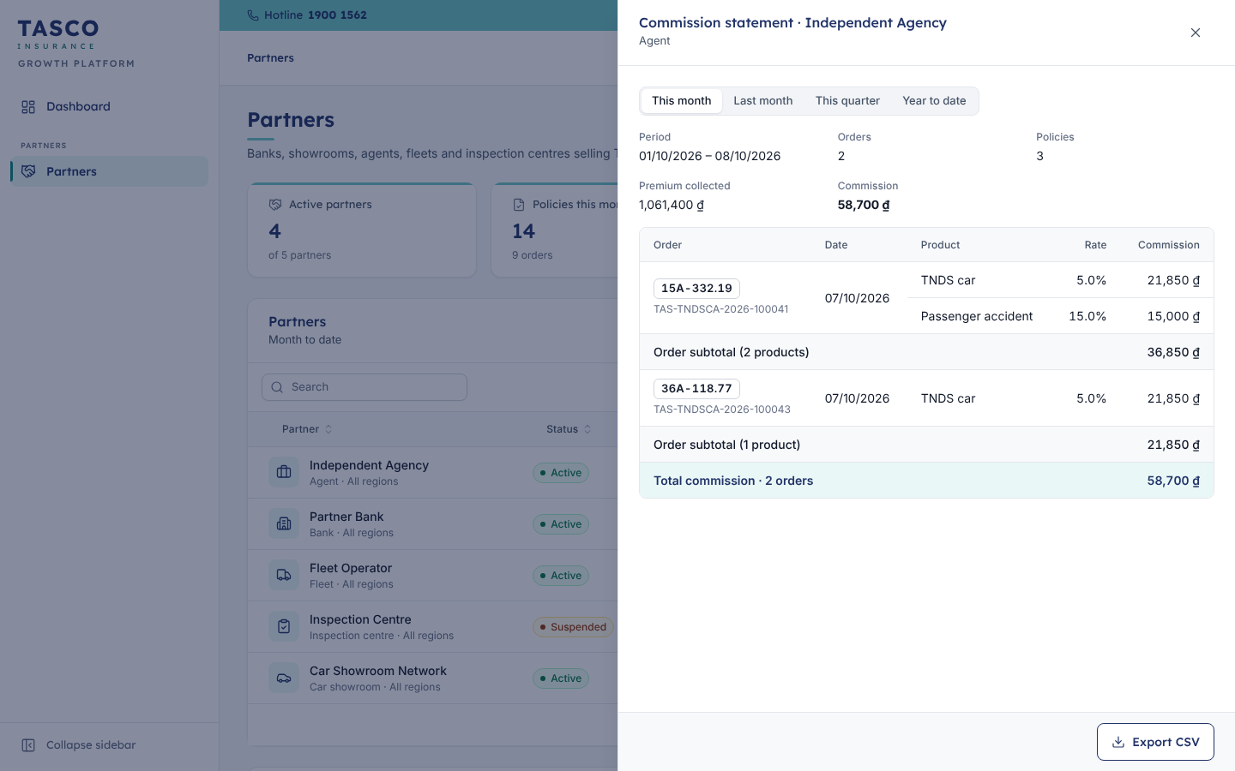
Figure 33 – Commission statement

What to check
- Keys close to expiry: issue a replacement before the old one expires.
- Partners with keys but no sales: their integration may be stuck.
- Commission rates in the statement match the partner agreement; rate changes go through the Partner commission rule set and compliance approval.

Administrator and support

What the role is for
The administrator manages staff accounts and roles and has read access to operations, the audit trail and the rules. The support engineer looks after the platform’s integrations and background jobs. For separation of duties, an administrator cannot also hold a business role such as rule author, approver, data steward, telesales or partner manager, and does not see customer personal data. Administrators need two-step verification.
Incident handling, monitoring and configuration are described in TGP-OPS-01 Runbook and Support Guide.

Daily routine
- Administrator: review Users for locked accounts and pending two-step set-ups; process joiners, movers and leavers.
- Support engineer: open Operations; check integration health, failed jobs and the event backlog.

Manage users
The Users page shows Active users, Two-step verification on, Locked out and Disabled. The chips All, Active, Locked, Disabled and MFA setup pending filter the list. Each row shows the user, roles, region, two-step status, last sign-in, status and the next step.
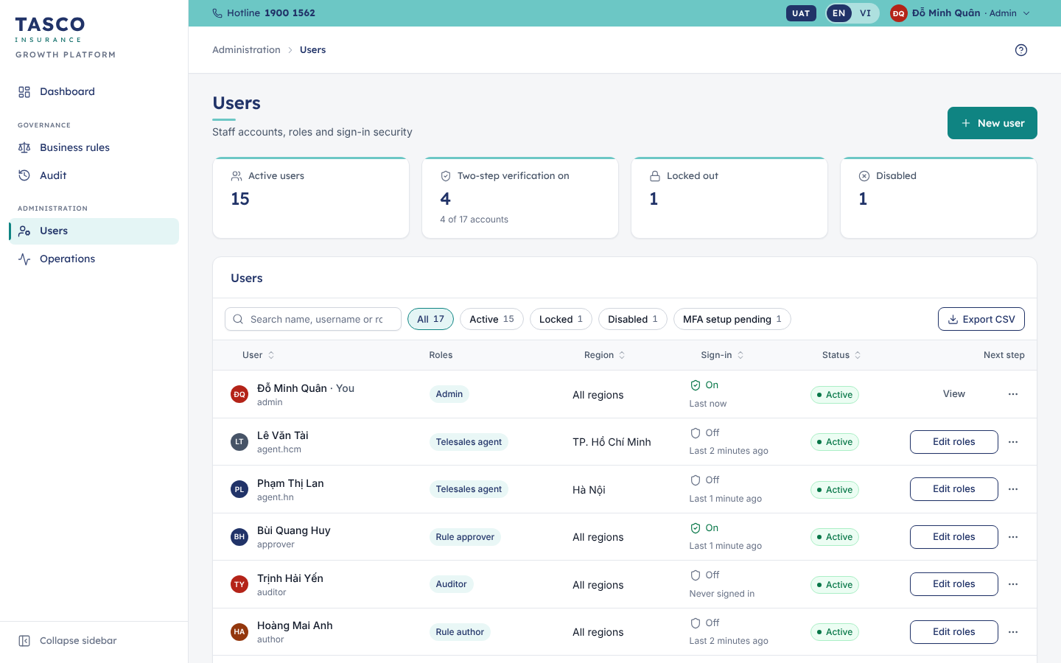
Figure 34 – Users

Create a user
- Select New user.
- Enter the Full name and the Username (lower-case letters, digits, dots or dashes).
- Choose the Roles. If two roles may not be held by one person, a Separation of duties message names the pair. Roles that need two-step verification show “Required for the selected roles”.
- Choose the Data region, which limits which customers the user can see.
- Select Create user.
- The Temporary password dialog shows the password once. Copy it, select I have copied it and give it to the user over a separate channel. The user must change it at first sign-in.
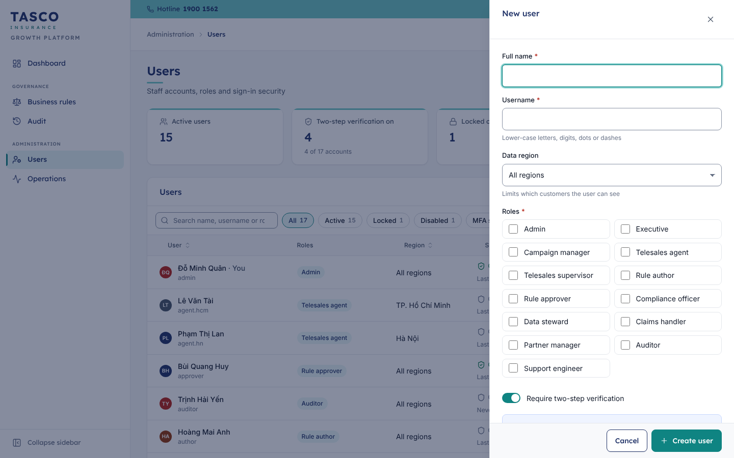
Figure 35 – New user

Change roles, unlock, reset or disable
Use the row’s primary action or More actions:
Action | Effect
Edit roles | Change roles and region. Open sessions are signed out so the new access applies at once. You cannot change your own roles.
Unlock | A locked user can sign in again straight away
Reset two-step verification | The user sets up the authenticator app again at next sign-in, for example after losing a phone
Reset password | Creates a temporary password, shown once; the user must change it at sign-in
Disable / Enable | A disabled user is signed out and cannot sign in until enabled
For a leaver, disable the account on the last working day. For a mover, edit the roles and region; never share accounts.

Monitor operations
- Select Operations in the sidebar.
- The tiles show Integrations operational (for example “8 of 9”), Failed jobs (24 h), Events waiting and Audit records.
- Integration health has one card per integration: TASCO core rating, TASCO product catalogue, policy issuance, VETC wallet, TASCO payment gateway, voice assistant, app push, Zalo ZNS and SMS brandname. Each card shows the status (Operational, Recovering or Outage), the mode (Live or Simulated), latency, last call and when it was checked. The rating card also shows the Rating source and the catalogue card the Last sync.
- Background jobs lists each job with its schedule, last run and next run.
- Event backlog shows events waiting, processed and in the dead letter. Active rule versions lists the version in force for each rule set.
Select Refresh to reload the page.
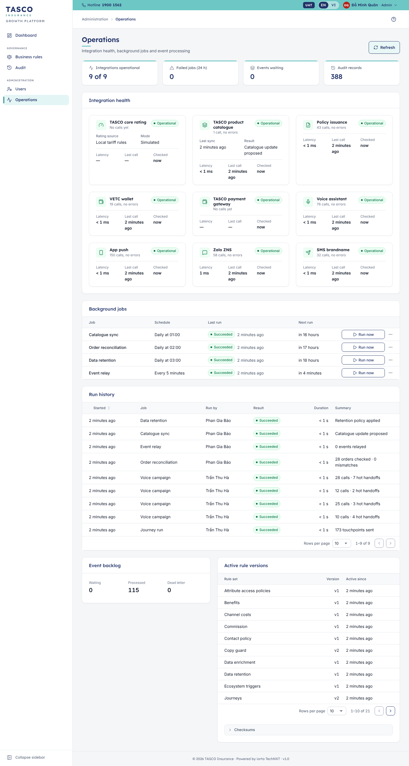
Figure 36 – Operations
Job | Schedule (Vietnam time) | What it does
Catalogue sync | Daily at 01:00 | Compares the product catalogue with TASCO core and proposes changes for approval
Order reconciliation | Daily at 02:00 | Checks orders against payments and policies and reports mismatches
Data retention | Daily at 03:00 | Applies the data retention policy
Event relay | Every 5 minutes | Delivers pending platform events

Run a job by hand
Support engineers and administrators can run a job outside its schedule, for example after an integration outage.
- On the job’s row, select Run now.
- Read the confirmation: the job runs against live data and is recorded in the audit trail. Confirm.
- The toast reports “Job finished”. View history lists each run with the start time, who ran it (Scheduler or a staff member), result, duration and summary.
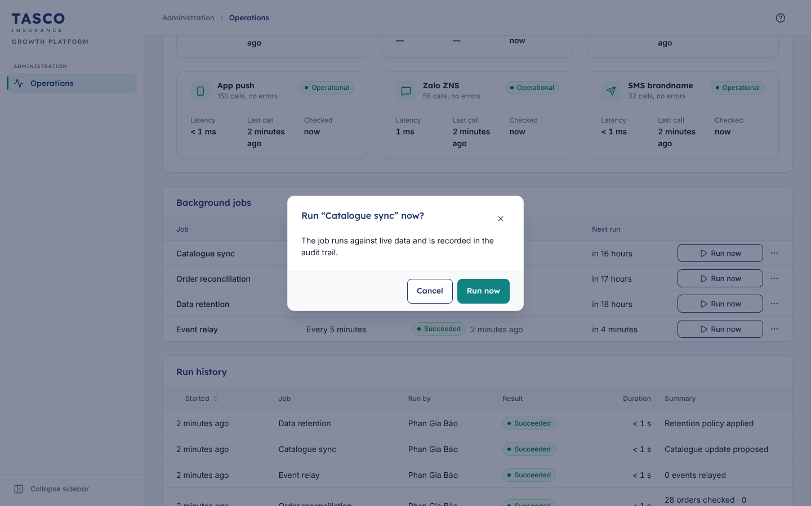
Figure 37 – Run a job

What to check
- Any integration not Operational: follow TGP-OPS-01 Runbook and Support Guide.
- Failed jobs and dead-letter events.
- Accounts locked repeatedly, and accounts not used for 90 days.

Auditor

What the role is for
Internal audit reviews who did what and when. The auditor reads the audit trail with technical details, the business rules and their version history, and the Dashboard. The role cannot change anything.

Daily routine
There is no fixed routine. Typical reviews are monthly sign-in activity, all rule changes in a period, changes to user roles, and claim decisions.

Review the audit trail
- Select Audit in the sidebar. The integrity banner shows whether the chain of records is intact.
- Filter by Person, Activity type, Object and dates, or search.
- Select a record. As an auditor you also see Technical details, collapsed by default: the record ID, action code, object and actor references, the record hash and the previous record’s hash, and the raw details. The IP address is shown for sign-in events.
- Export CSV keeps the filtered list as working-paper evidence.
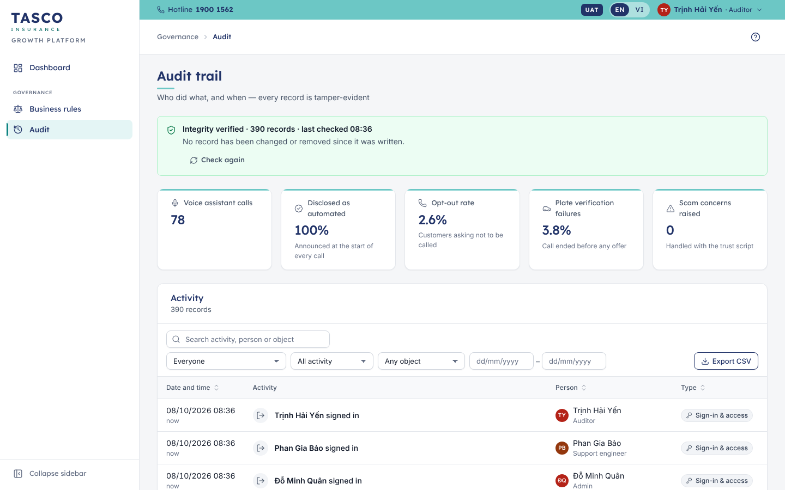
Figure 38 – Audit trail
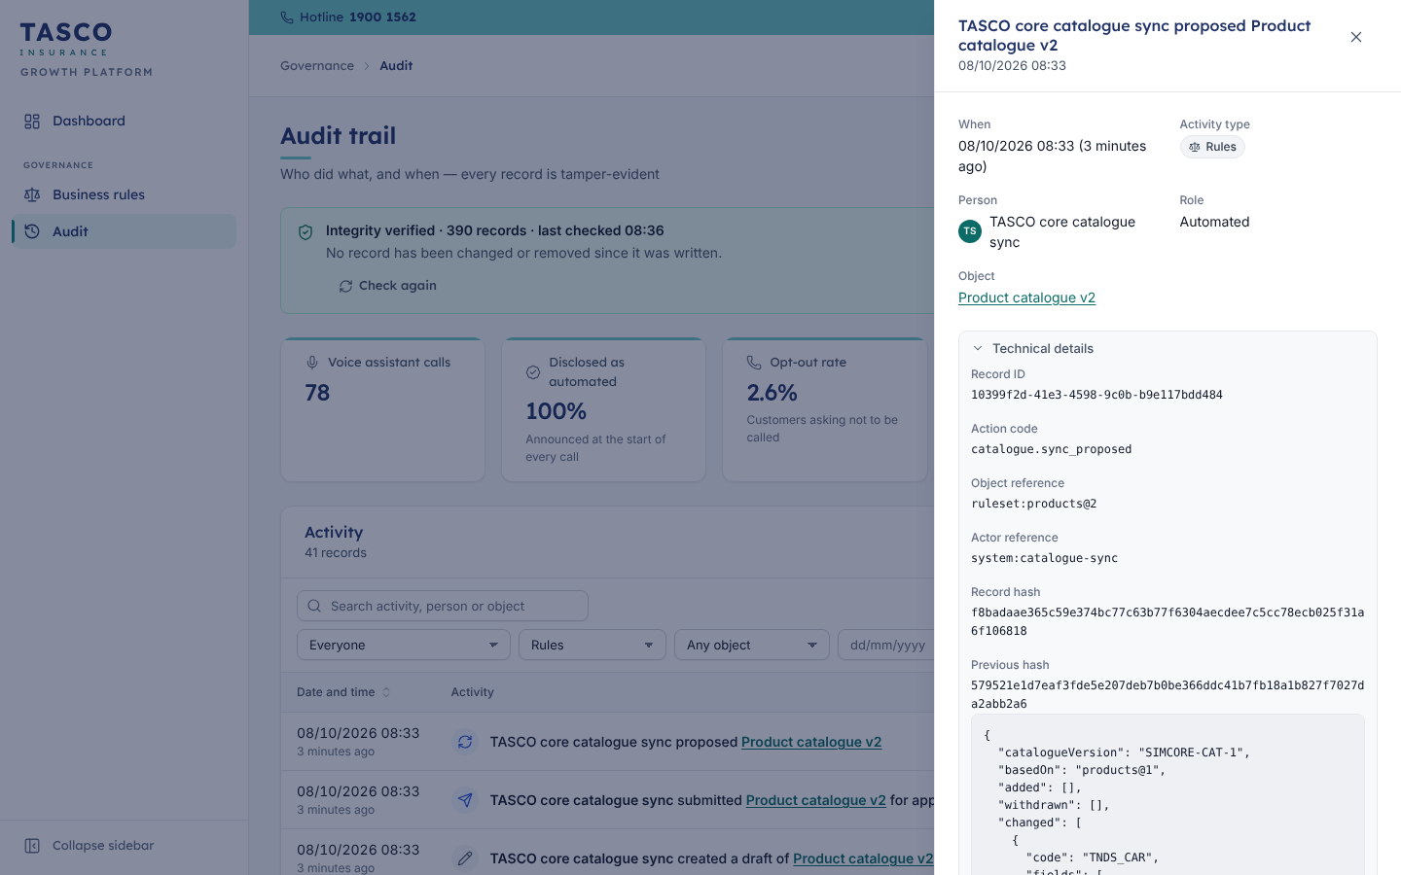
Figure 39 – Audit record with technical details

Review sign-in activity
Choose Sign-in & access under Activity type. Records show successful sign-ins, wrong passwords, unknown usernames, lockouts, unlocks, password resets and two-step verification resets.
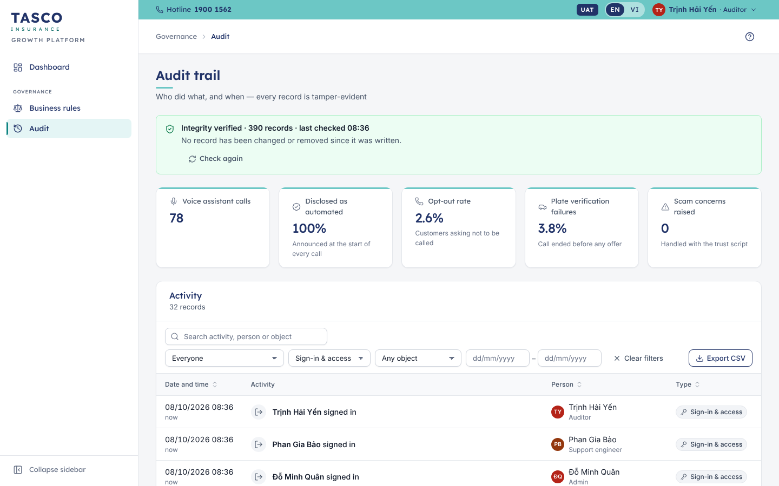
Figure 40 – Sign-in activity

Review rule versions
Open Business rules and any rule set. Version history lists every version with its status, change note, author and last activity. The Workflow card of a version shows who drafted, submitted, approved or rejected it, with comments and times. Compare with the audit trail filtered to Rules.

What to check
- Integrity verified.
- Every active rule version approved by someone other than its author.
- Role changes for administrators and approvers backed by a request.
- Claim approvals and payments within the approver’s authority.

Troubleshooting and support

Common problems
Problem | Likely cause | What to do
“Incorrect username or password.” | Typing error, Caps Lock, wrong account | Check and try again. Five failures lock the account for 15 minutes.
“Your account is temporarily locked…” | Five failed attempts | Wait 15 minutes or ask an administrator to unlock it
“Too many attempts. Please wait a moment and try again.” | Many sign-in attempts from the same computer | Wait a minute
“Incorrect code. Check the 6 digits and that your phone’s clock is correct.” | Old or mistyped code, or the phone clock is wrong | Use the newest code; set the phone’s time to automatic
“This code has already been used…” | Each code works once | Wait for the next code (up to 30 seconds)
“Your sign-in session expired. Please sign in again.” | More than 5 minutes on the code step | Start again from the password
A QR code appears although you set up the app before | An administrator reset your two-step verification | Scan the new code and remove the old entry from the app
Lost or replaced phone |  | Ask an administrator to reset your two-step verification
“Session expired — please sign in again” | The 30-minute session ended | Sign in again
A page is missing from the sidebar, or “You do not have access to this page.” | Your role does not include it | Ask your manager to request a role change
Names or phone numbers are masked | Your role may not see personal data | Expected
A customer outside your region cannot be opened | Region limits | Expected; ask your supervisor to reassign
“… was modified by someone else” | Another user changed the same record | Reload the page and repeat your change
“Quote expired — please re-quote” | Quotes are valid for 24 hours | Calculate the price again
“Upstream service unavailable” | TASCO core, the VETC wallet or a messaging provider is temporarily down | Try again later; nothing was completed. Report it if it lasts.
The page looks wrong or blank | Browser cache or an unsupported browser | Reload with Ctrl+F5; use a supported browser

Getting help
- Select Help in the top bar for a short explanation of the page.
- Ask your team champion, trained during roll-out, for “how do I…” questions.
- Contact the service desk for access, lockouts and errors. Give the error reference (for example “Ref. 7F3C2A1B”), the page, the time and what you were doing. Never put customer personal data in a ticket; use the plate only.
The hotline 1900 1562, info@baohiemtasco.vn and baohiemtasco.vn shown in the console are TASCO Insurance’s customer channels. Give them to customers who ask how to reach TASCO.

Responsible use
- Use only your own account. Never share passwords or authenticator codes.
- Open customer records only when your work needs it.
- Do not copy customer data into spreadsheets, chat apps or e-mail, except exports your role needs and your manager approves.
- Never take payment, payment details or OTP codes by phone.
- Report a suspected security or privacy incident to the service desk at once.

Appendix

Role and permission summary
Role | Main pages | Personal data | Two-step
Executive | Dashboard | No | No
Campaign manager | Dashboard, Leads, Customer 360, Voice assistant, Journeys, Campaigns, Telesales inbox (read), Business rules (read) | Masked | No
Telesales supervisor | Dashboard, Leads, Customer 360, Telesales inbox (all in region, reassign), Voice assistant | Yes | No
Telesales agent | My work today, Leads, Customer 360, Telesales inbox (own and unassigned in region), Voice assistant | Yes | No
Rule author | Dashboard, Business rules (draft and submit) | No | No
Rule approver | Dashboard, Business rules, Approvals, Audit | No | Yes
Compliance officer | Dashboard, Business rules, Approvals (including restricted), Audit, Customer 360 | Masked | Yes
Data steward | Dashboard, Data quality, Leads, Customer 360 (correct expiry) | Yes | Yes
Claims handler | Claims, Customer 360 | Masked | No
Partner manager | Dashboard, Partners | No | No
Administrator | Dashboard, Users, Operations, Audit, Business rules (read) | No | Yes
Support engineer | Operations | No | No
Auditor | Dashboard, Audit (with technical details), Business rules (read) | No | No
Pairs of roles one person may not hold: administrator with any business role (rule author, rule approver, compliance officer, data steward, telesales agent, telesales supervisor, campaign manager, partner manager); rule author with rule approver; rule author with compliance officer.

Page names in Vietnamese
English | Tiếng Việt
Dashboard | Tổng quan
Leads | Khách hàng tiềm năng
Telesales inbox | Hộp việc telesales
Voice assistant | Trợ lý gọi tự động
Journeys | Hành trình
Campaigns | Chiến dịch
Claims | Bồi thường
Partners | Đối tác
Data quality | Chất lượng dữ liệu
Business rules | Quy tắc nghiệp vụ
Approvals | Phê duyệt
Audit | Nhật ký kiểm toán
Users | Người dùng
Operations | Vận hành
Customer 360 | Khách hàng 360

Glossary of status names

Telesales handoffs
Status | Tiếng Việt | Meaning
New | Mới | Waiting for a first call
In progress | Đang xử lý | An agent selected Call customer and owns the handoff
Callback | Hẹn gọi lại | The customer asked to be called at an agreed time
Won | Thành công | The customer agreed and pays in the app (final)
Lost | Không thành công | No sale, with a reason (final)

SLA chips
Chip | Meaning
On track | More than the warning window left (30 minutes for handoffs; 1 hour for claim acknowledgement; 24 hours for claim decision and payment)
Due soon | Inside the warning window
Breached | Past the deadline; the chip shows how long ago

Claims
Status | Meaning
Submitted | Reported by the customer in the app
Acknowledged | Received by TASCO; the customer has been told
Assessor assigned | A field assessor is named
Under assessment | The assessor is assessing the damage
Approved | Approved with an amount; awaiting payment
Paid | Payment recorded with a reference (closed)
Rejected | Rejected with a reason explained to the customer (closed)

Rule versions
Status | Meaning
Draft | Being edited by its author
Awaiting approval | Submitted; waiting for a second person
Active | In force for all customers
Replaced | Was active; replaced by a newer version
Rejected | Returned to the author with a reason

Leads, journeys and calls
Term | Meaning
Hot, Warm, Nurture | Lead tiers: score 70 or more, 45 or more, below 45
Scheduled, Done, Skipped, Cancelled | Touchpoint status; a skipped touchpoint shows why
Hot handoff to telesales | Call outcome: the customer wants an advisor
Link sent | Call outcome: a renewal link was sent to the app or Zalo
Call back later, No answer | Call outcomes for a later attempt
Already renewed elsewhere | The customer says they renewed with another insurer (becomes a data issue)
Opted out | The customer asked not to be contacted
Plate mismatch, Wrong person, Not verified | The call ended before any offer
Scam concern | The customer raised a trust concern

Data issues
Term | Meaning
High, Medium, Low | Severity of the issue
Confirmed current value, Corrected, Merged duplicates, Dismissed | How the issue was resolved

Partners, keys, users and integrations
Term | Meaning
Active, Suspended | Partner may or may not trade through the API
Active, Revoked | API key status; each key also shows its expiry date
Active, Locked, Disabled | User status; Locked clears after 15 minutes or on unlock
On, Setup pending, Off | Two-step verification status of a user
Operational, Recovering, Outage | Integration health
Live, Simulated | Whether an integration calls the real system or the sandbox

Sign-Off
Serial Number | Description | Owner | Status
1 | Role names, permissions and the roles that require two-step verification confirmed for production | TASCO IT Security | Open
2 | Session length (30 minutes) and lockout policy (5 failed attempts, 15 minutes) confirmed | TASCO IT Security | Open
3 | Service levels confirmed: first call on a telesales handoff within 2 hours; claim acknowledgement within 4 hours, decision within 5 days, payment within 3 days | TASCO Sales and TASCO Claims | Open
4 | Lost-handoff reasons, claim rejection reasons and data-issue dismissal reasons approved | TASCO Product Owner | Open
5 | Procedure for data subject access and erasure requests (no console screen in this release) to be confirmed by TASCO legal | TASCO Compliance | Open

Sign Off Date | Signature | Approved By | Department & Project Role
 |  | TASCO Insurance | Programme Sponsor
 |  | TASCO Insurance | Product Owner
 |  | iorta TechNXT | Business Analysis and User Experience



